- Bandhan Flexi Cap Dir, 7.2k, 0.96%, 13y, this is worst situaiton, after 10y not beated nifty 500 manish joined in 2024, see what happen here https://mutual-funds.ai/funds/flexi-cap/Bandhan-Flexi-Cap-Fund-Direct-Plan-Growth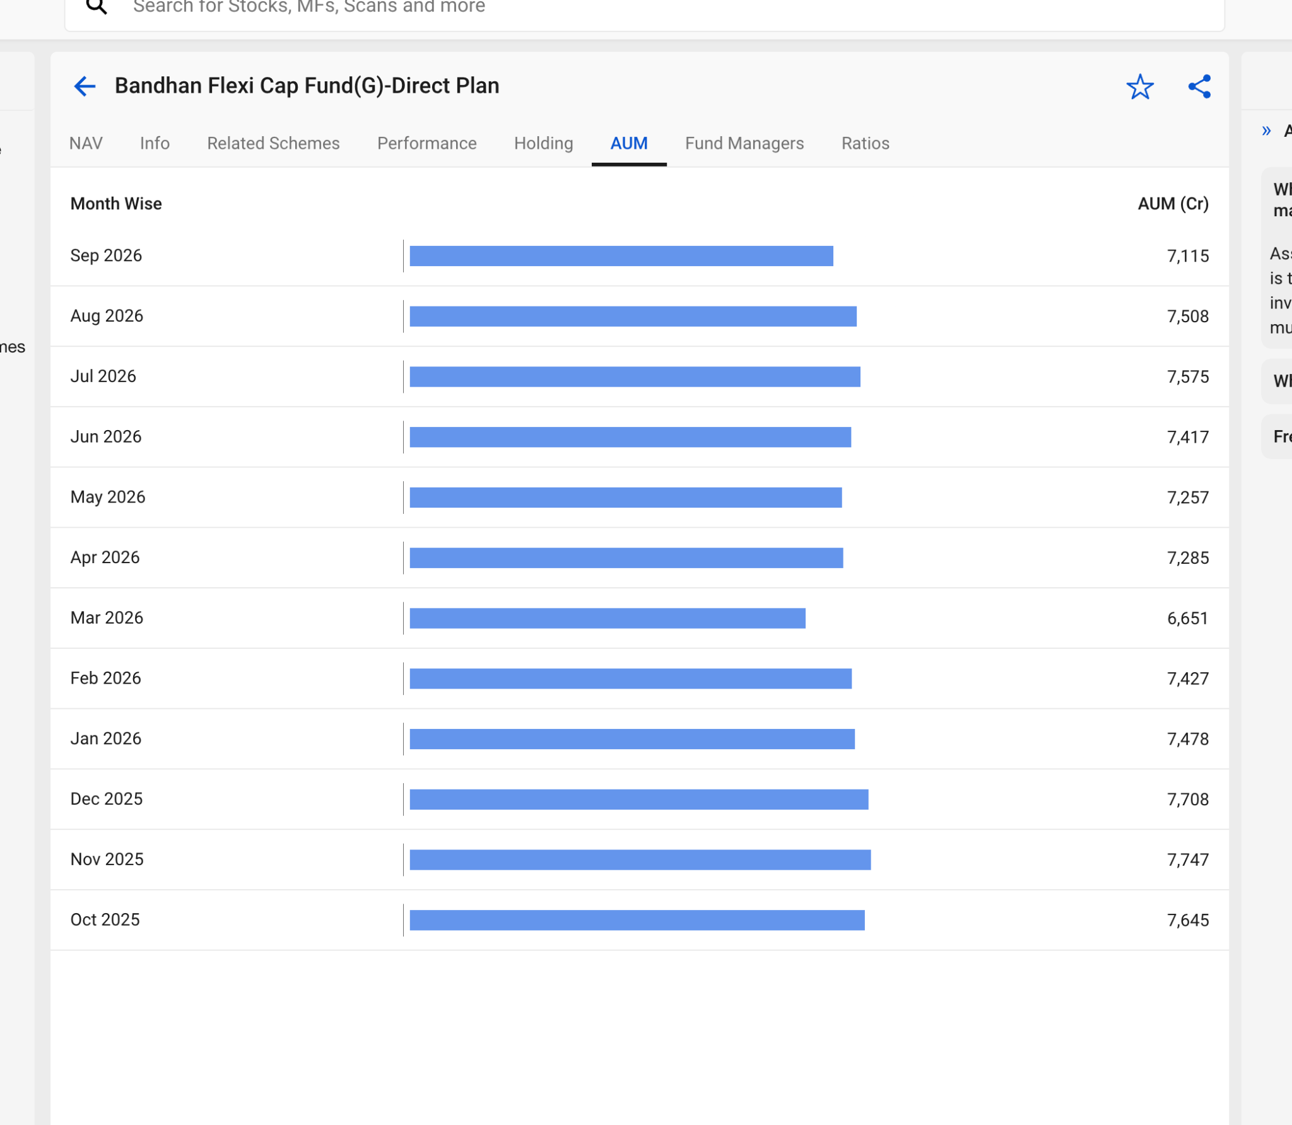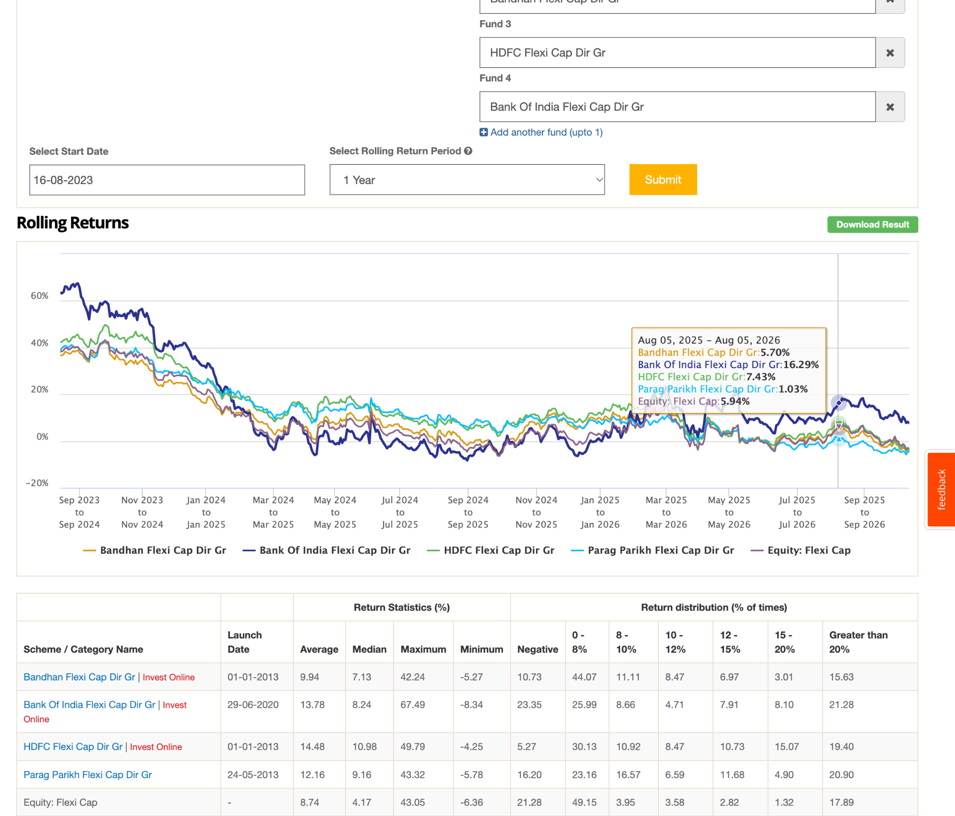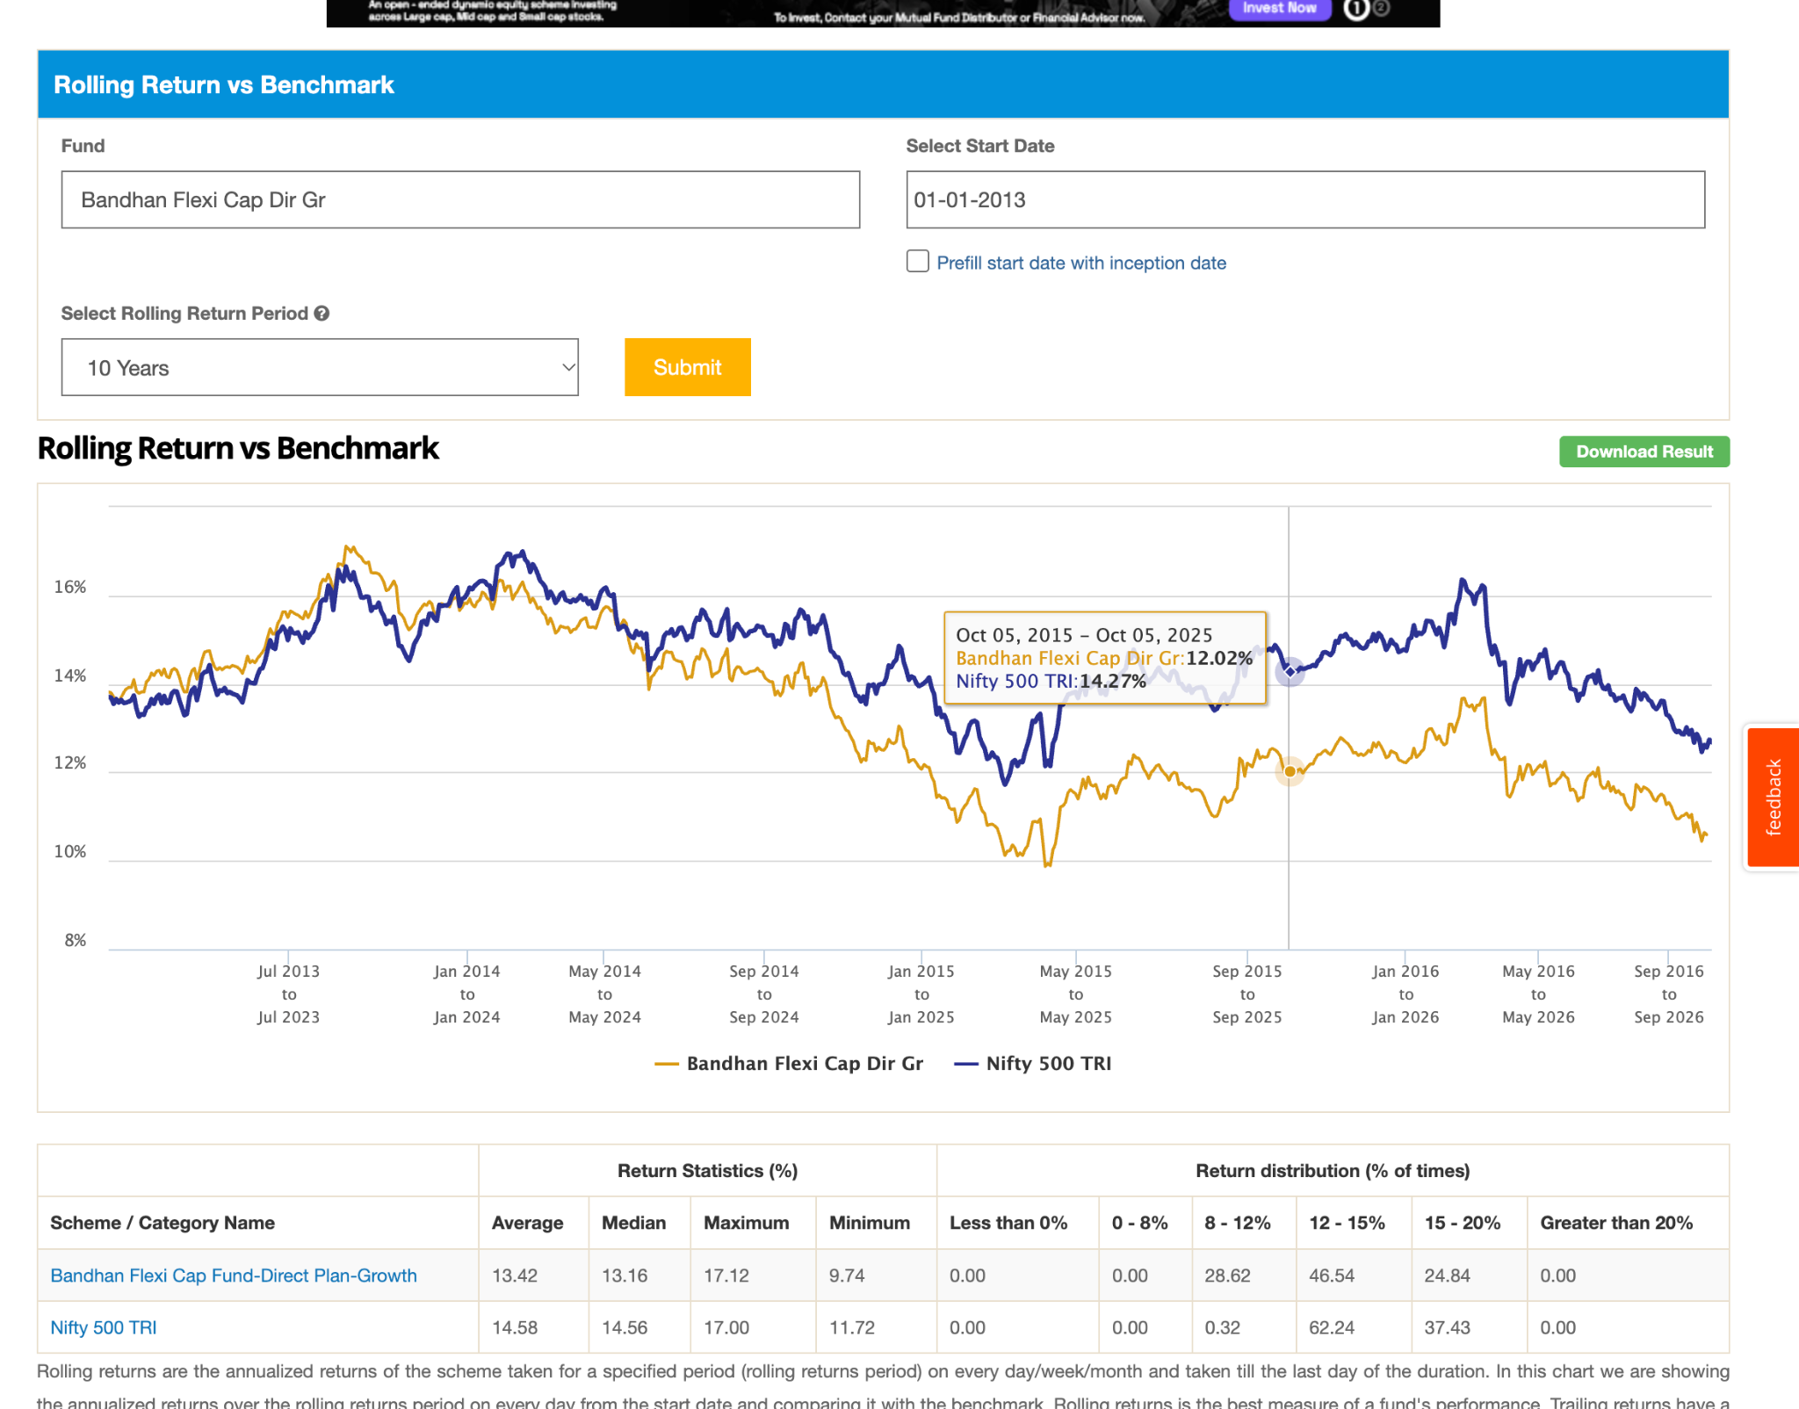
- Abakkus Flexi Cap Dir, 9month, but 7.5k crore amazing, 0.40%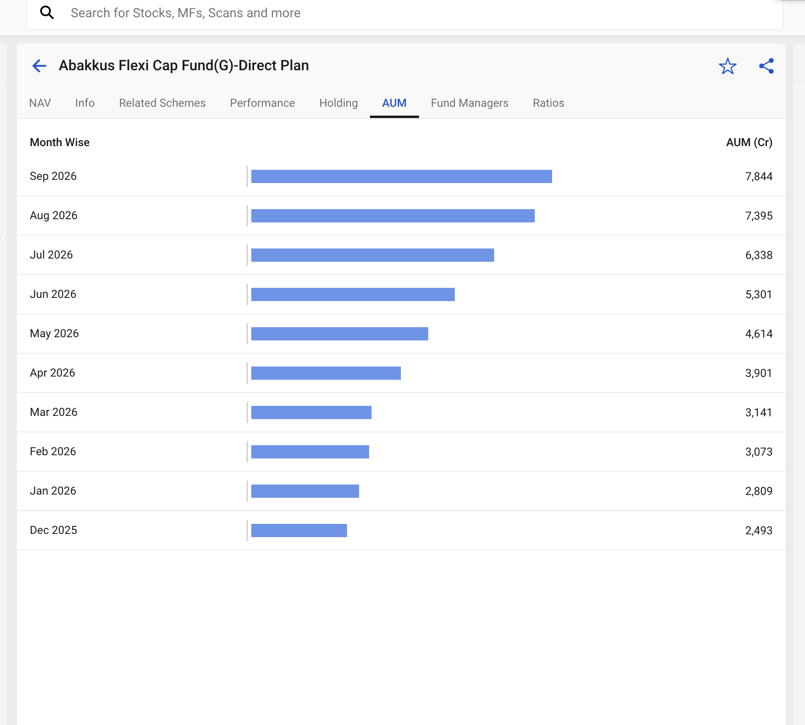
- Quant Flexi Cap Dir, 7.3k 0.58%, 13y, why this fund hasn't high aum ???, hith volatile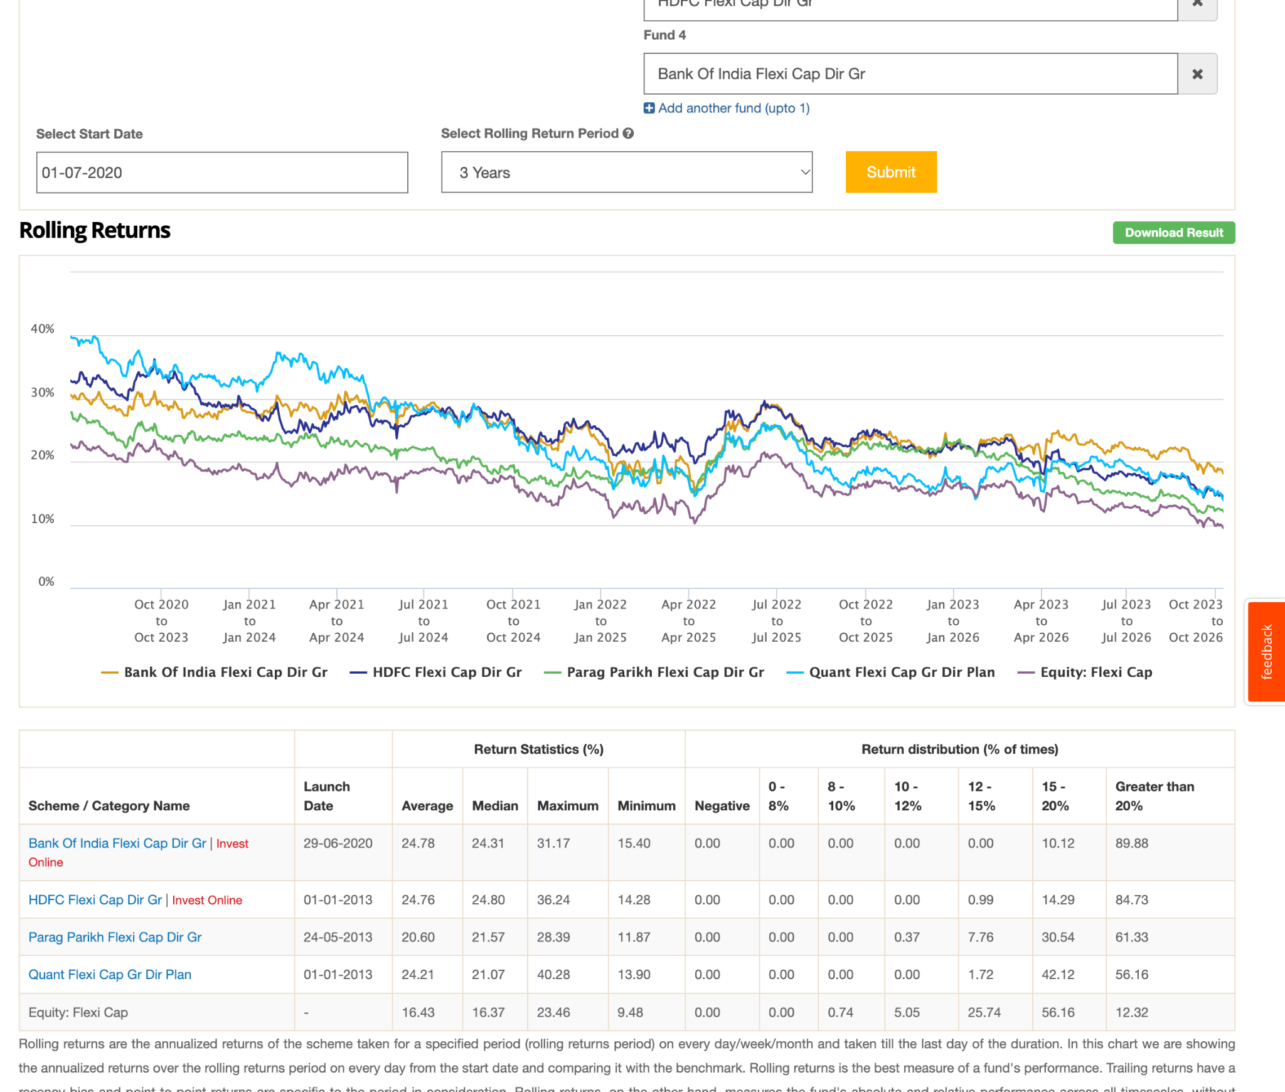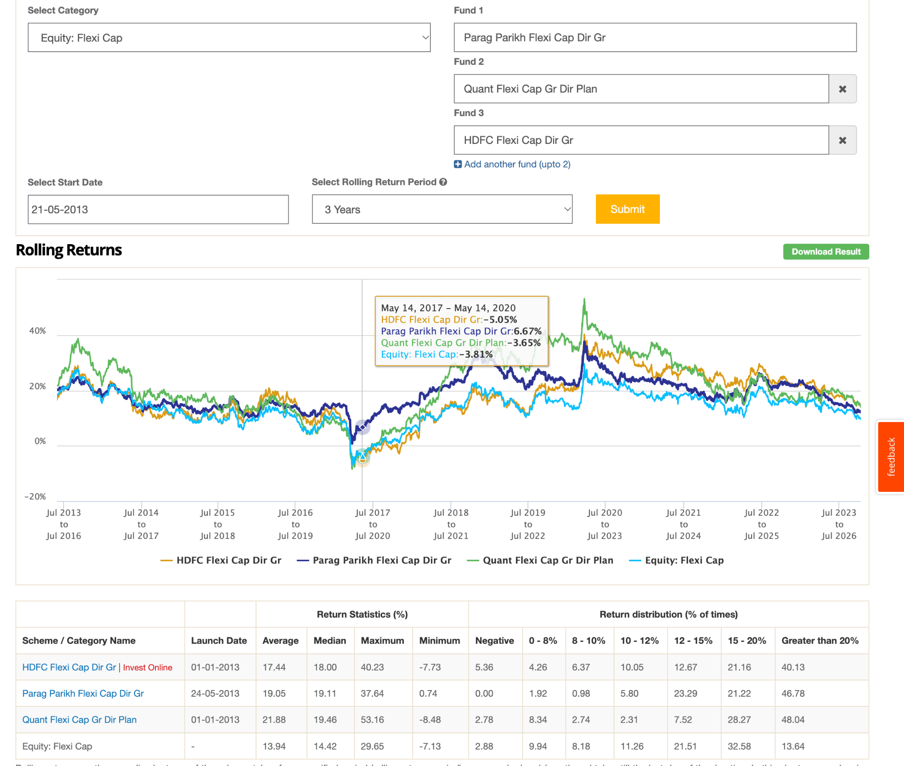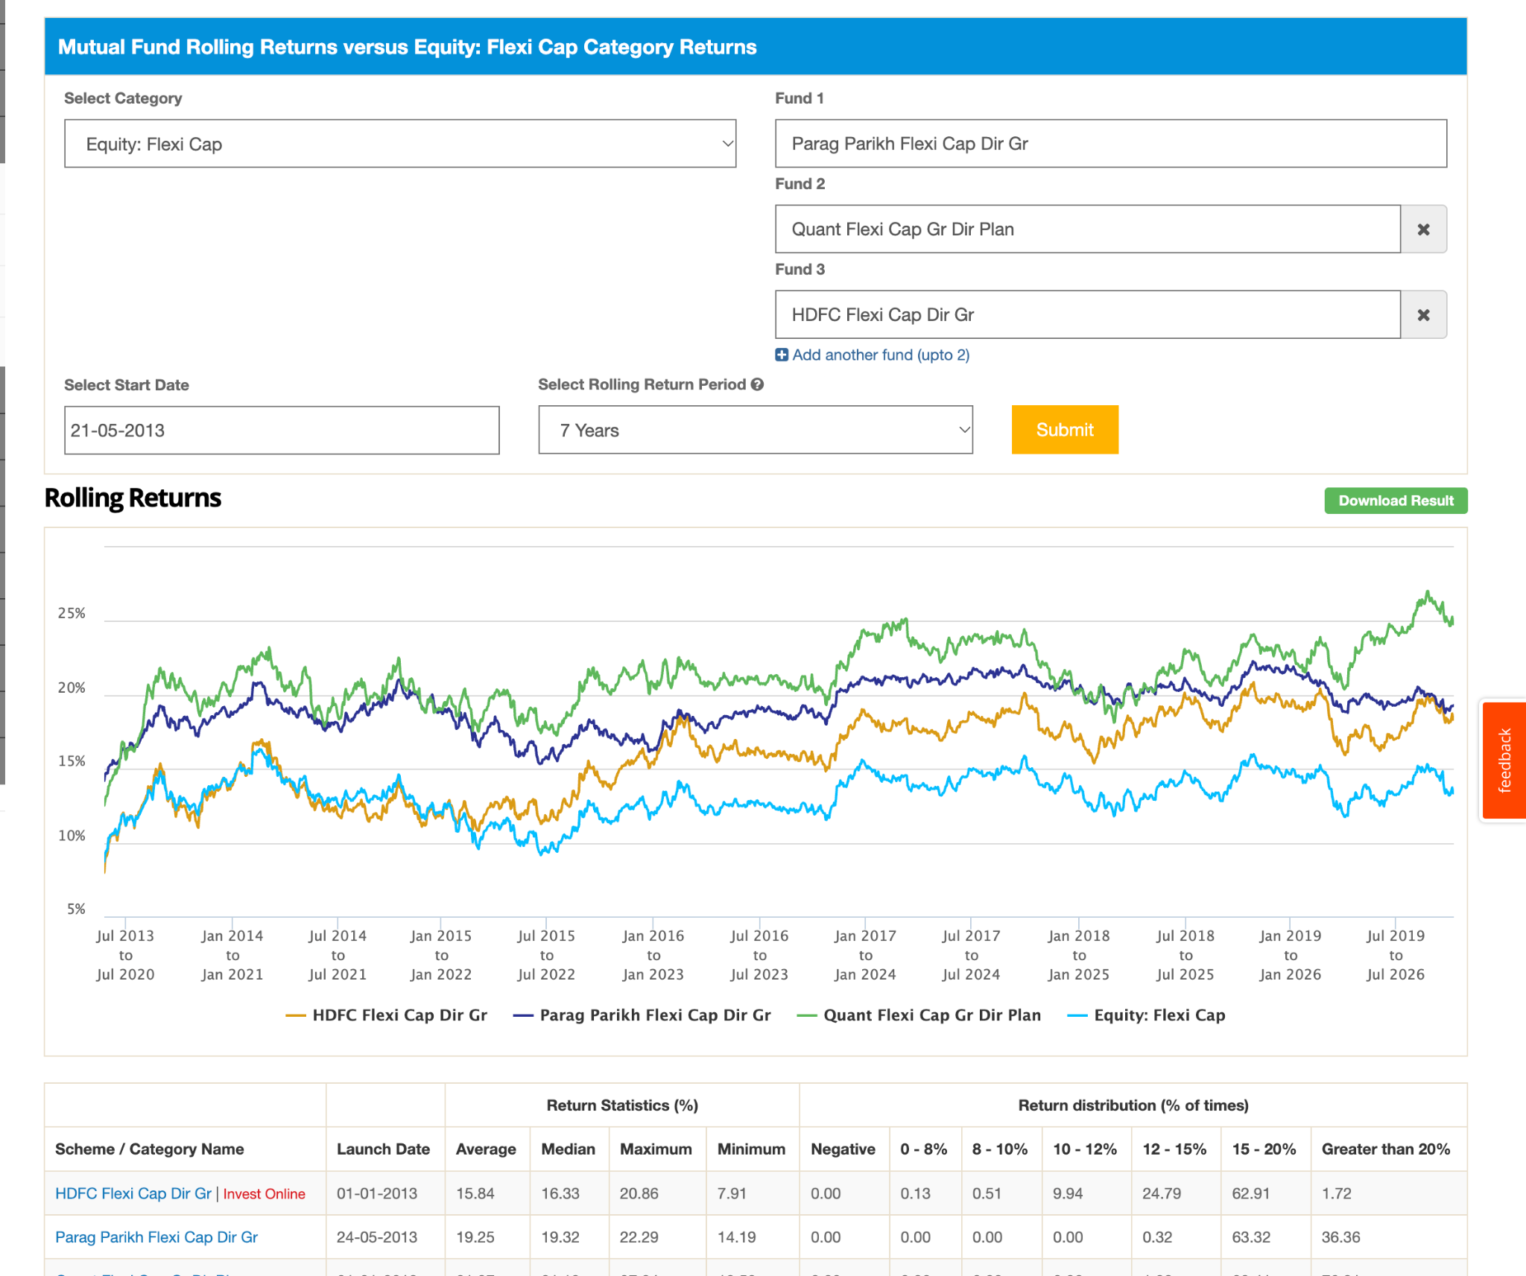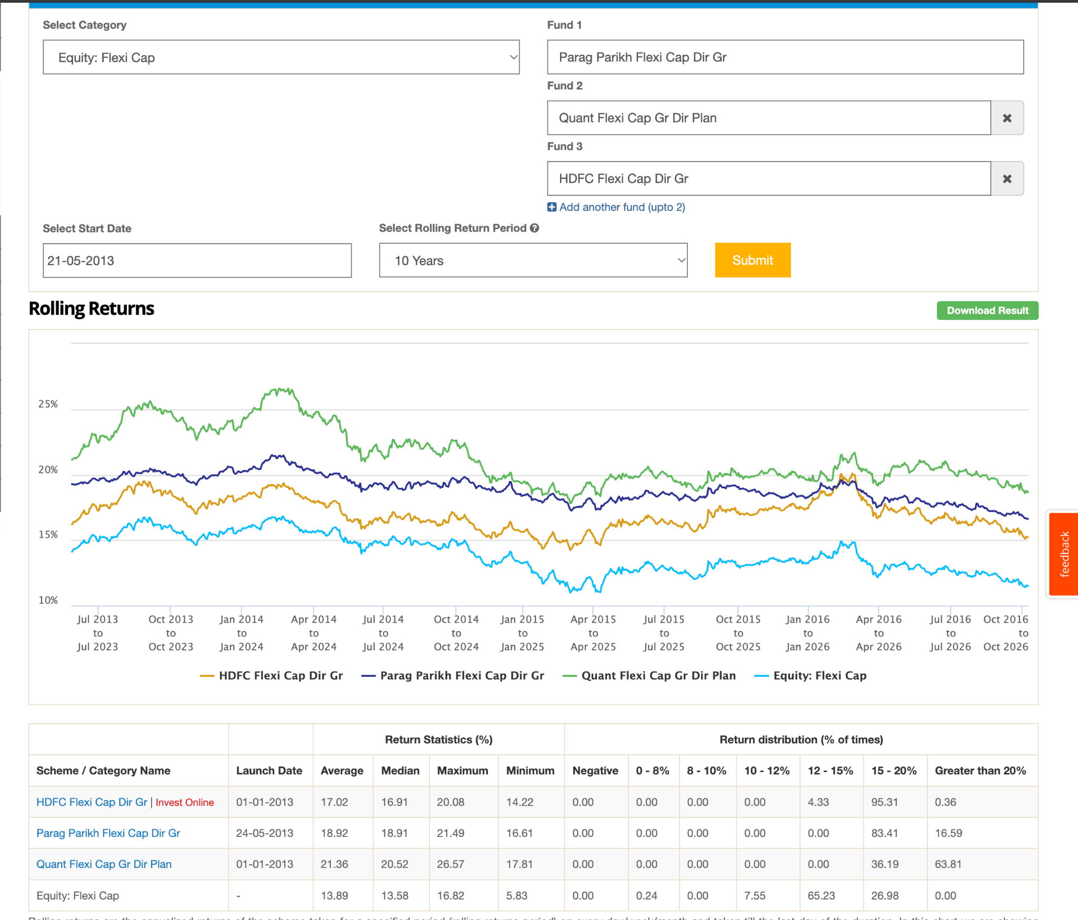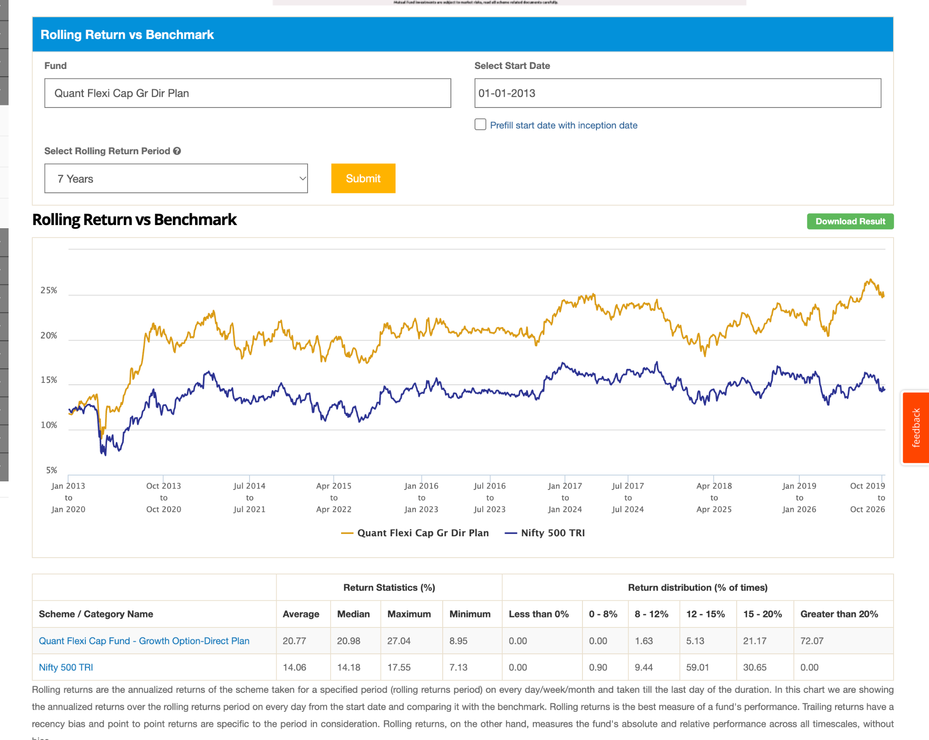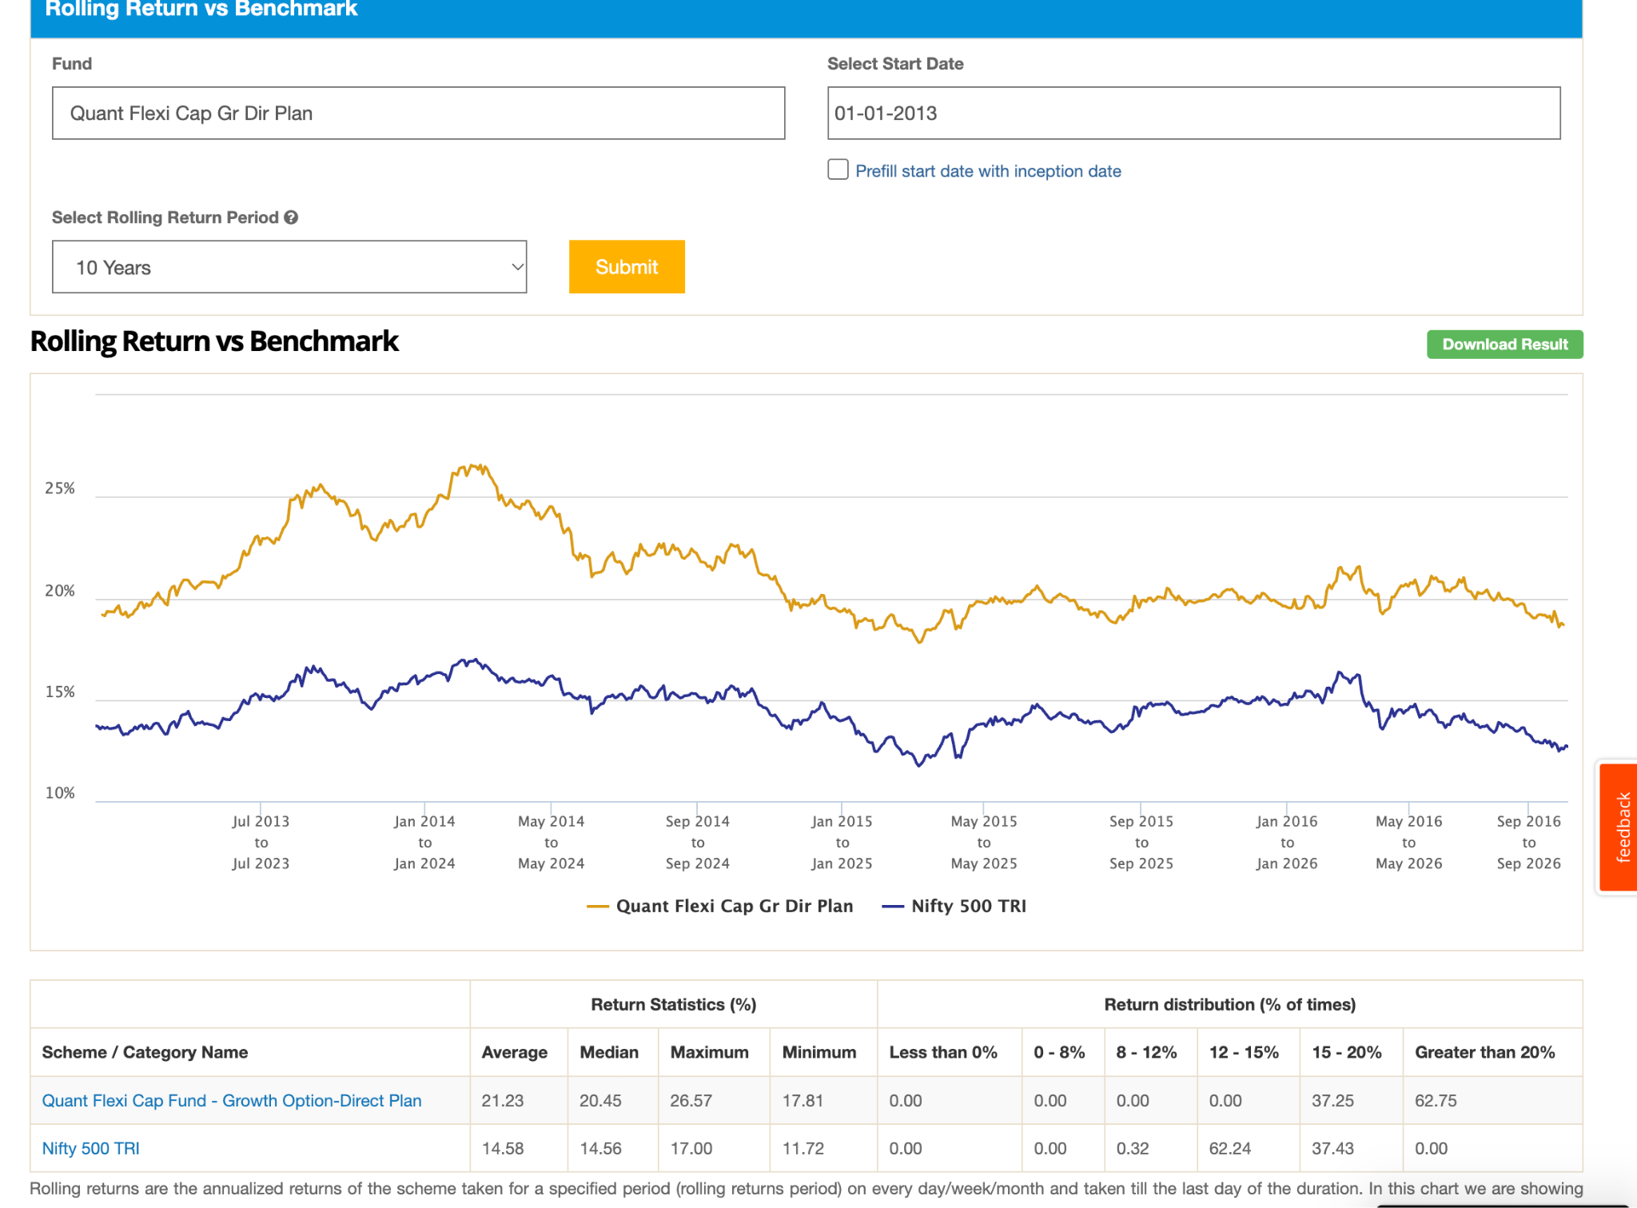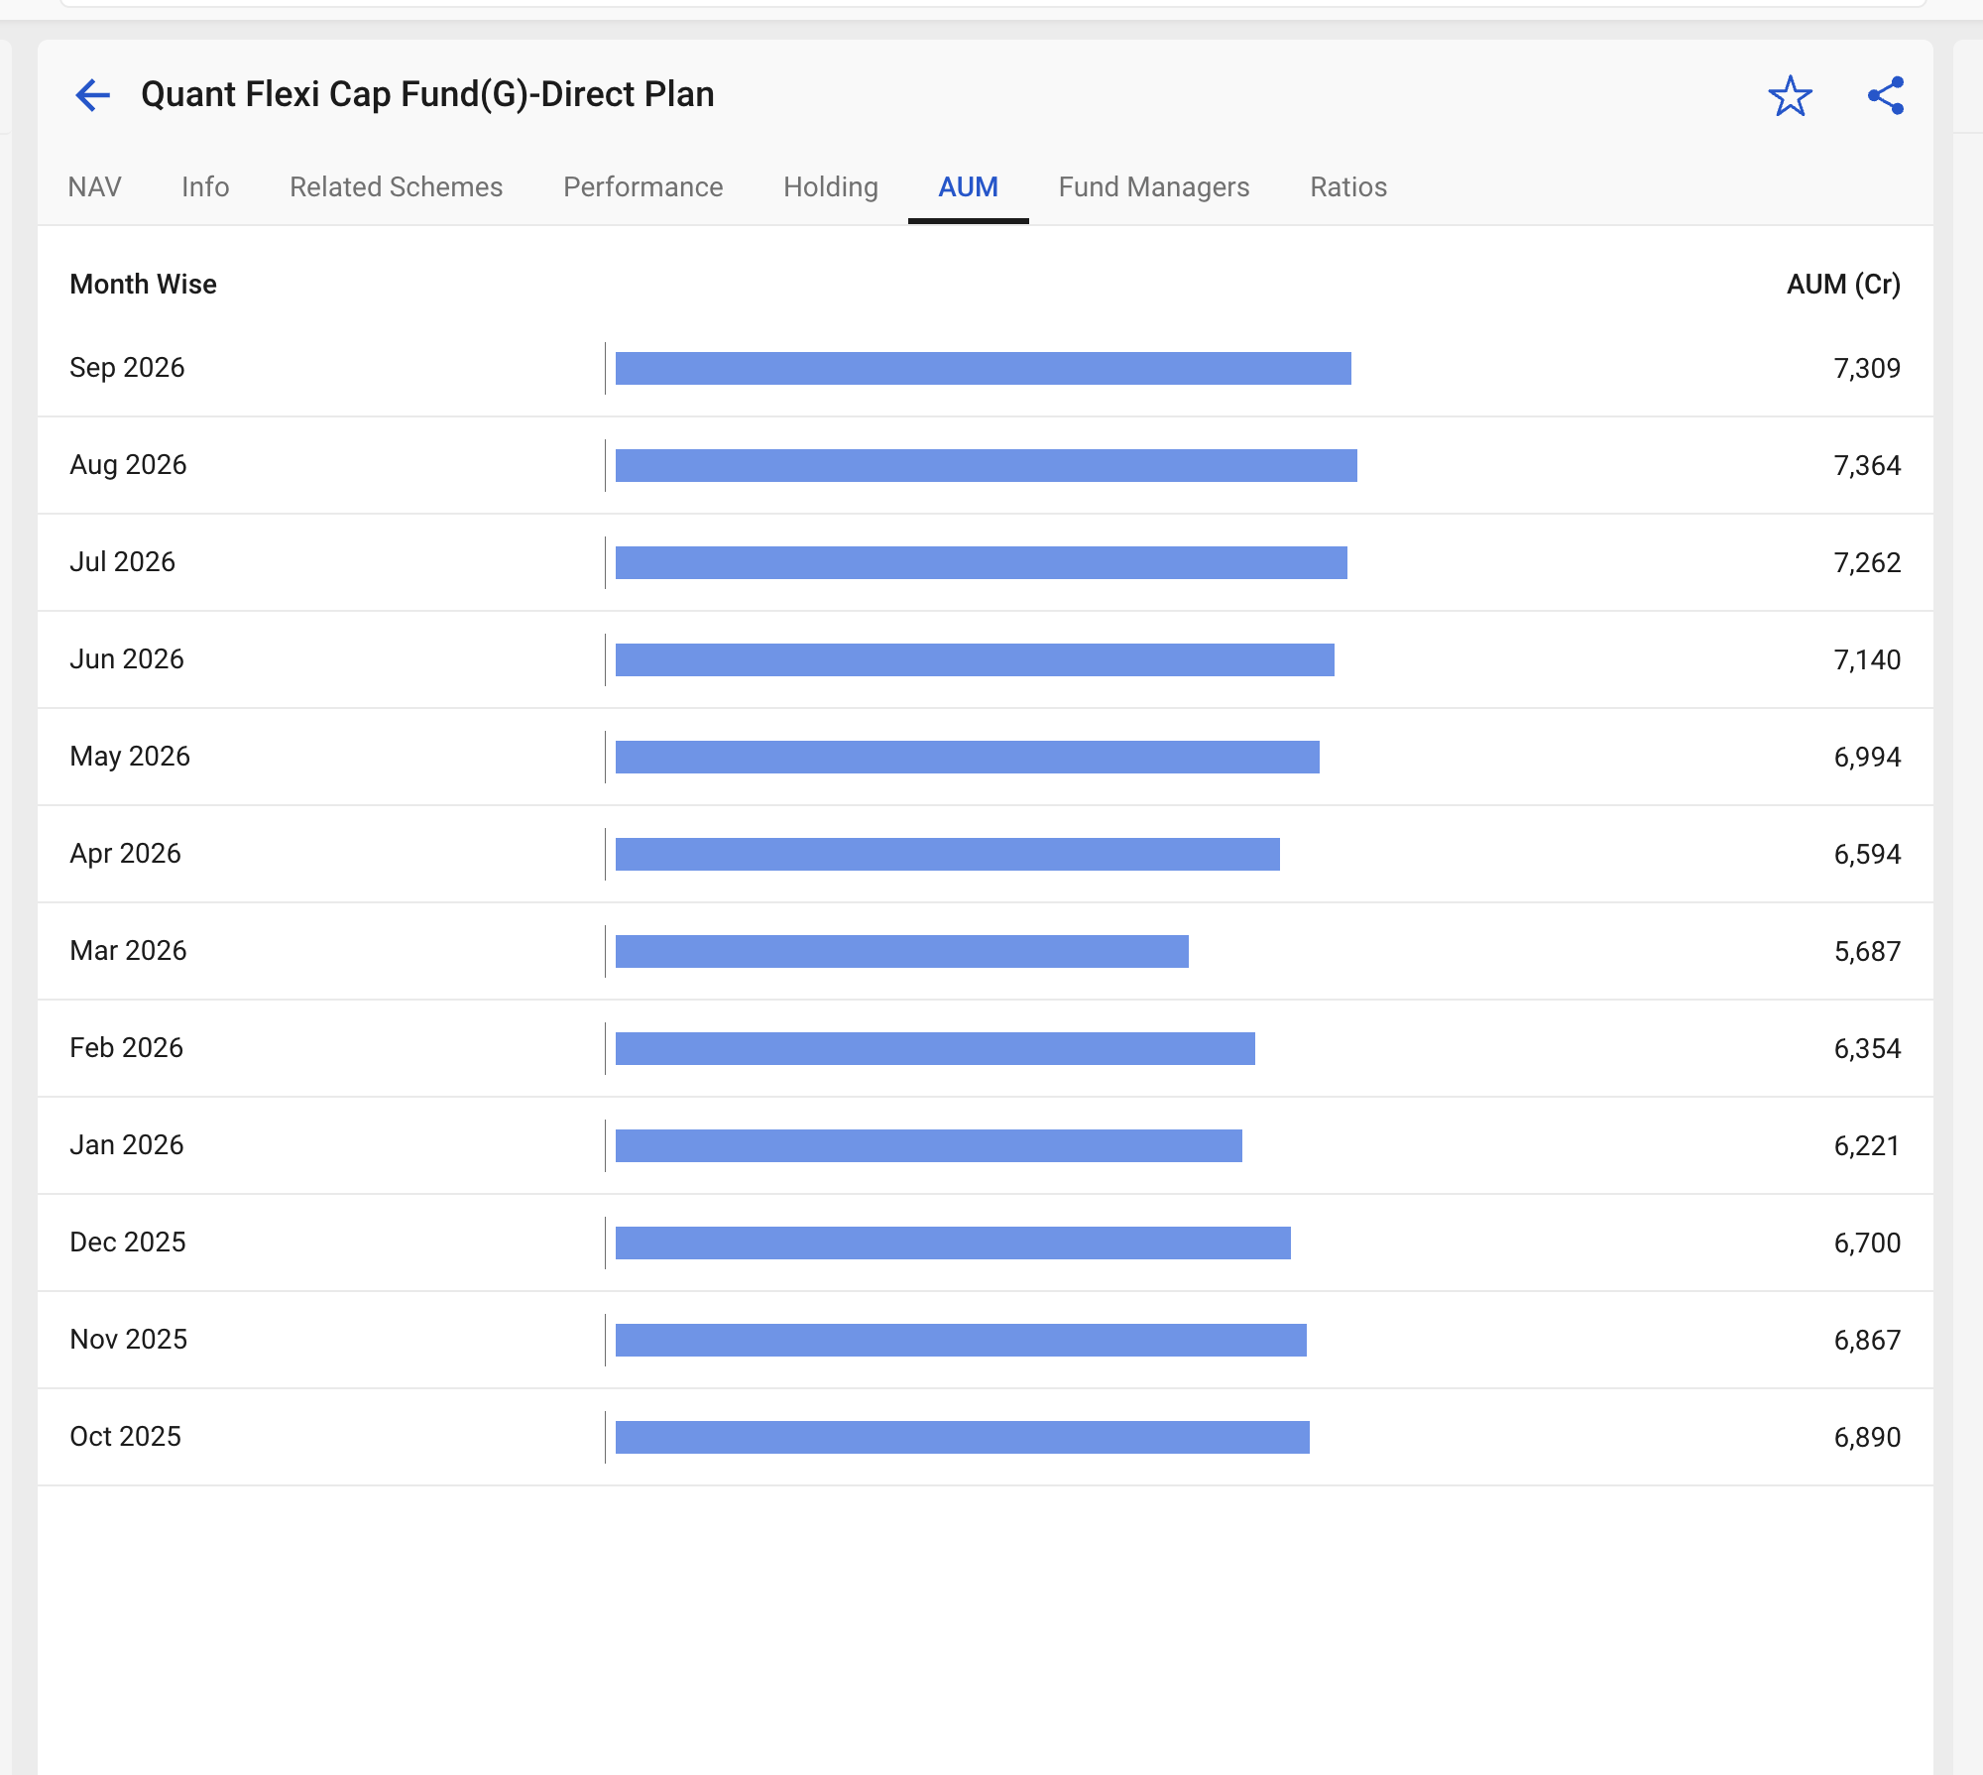
- HSBC Flexi Cap Dir, 5.8k , 0.91% , 13y, just beating 500, not generating high alpha, but why vc and groww gave 4* 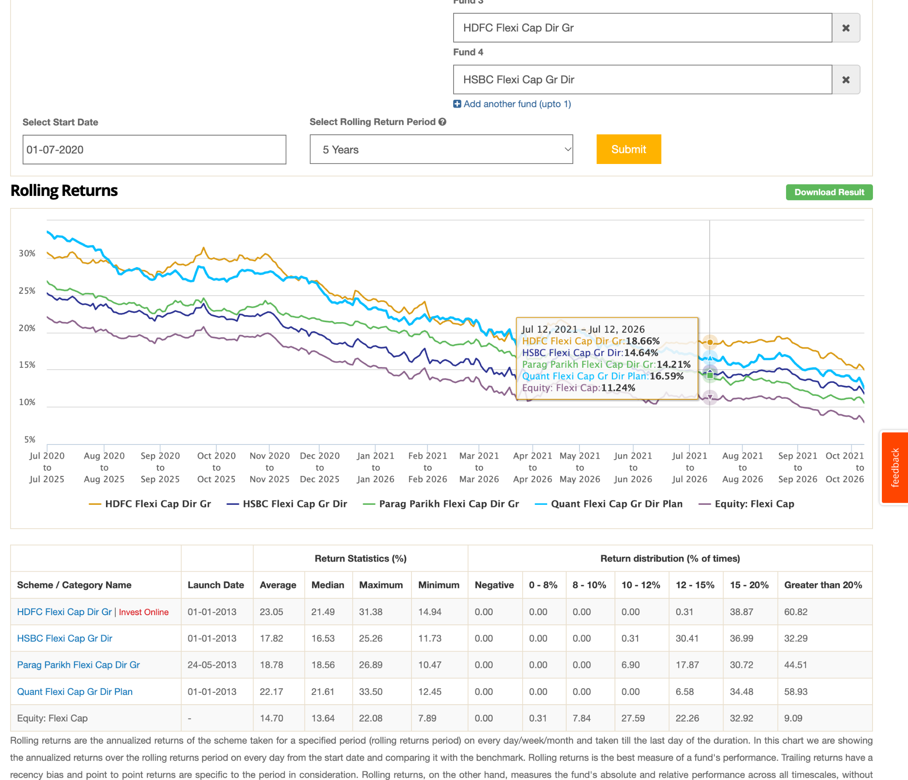
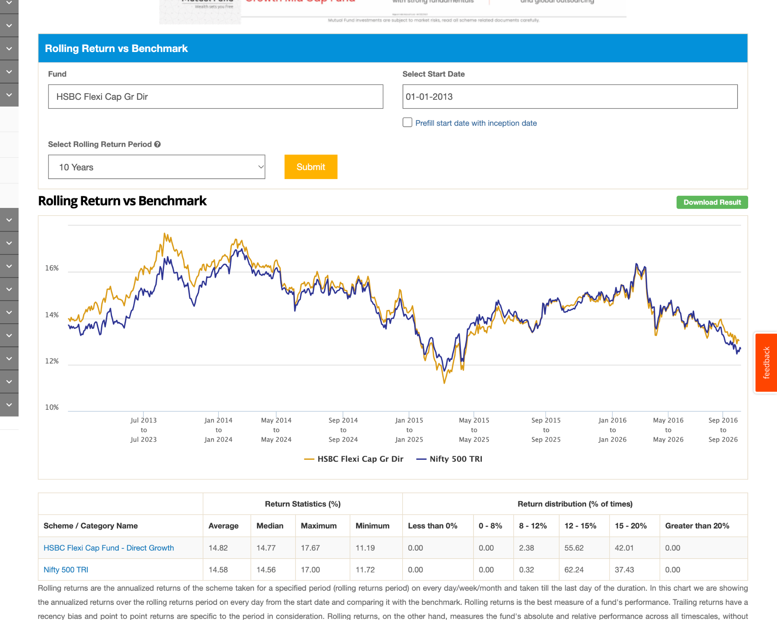
- PGIM India Flexi Cap Dir, 11y, 5.6k, 0.5, beating but not generating great alpha, though generate better than ppfcf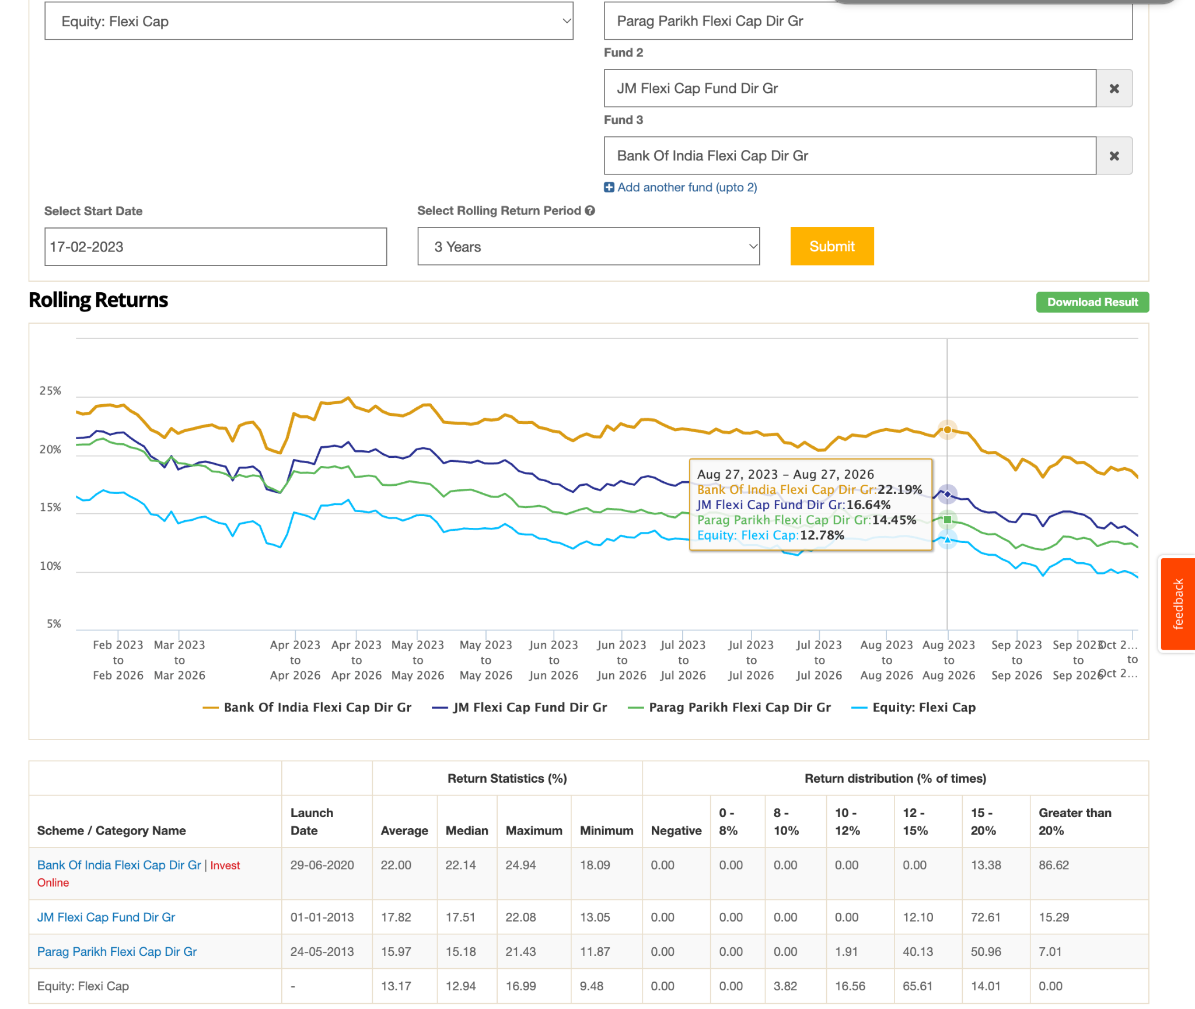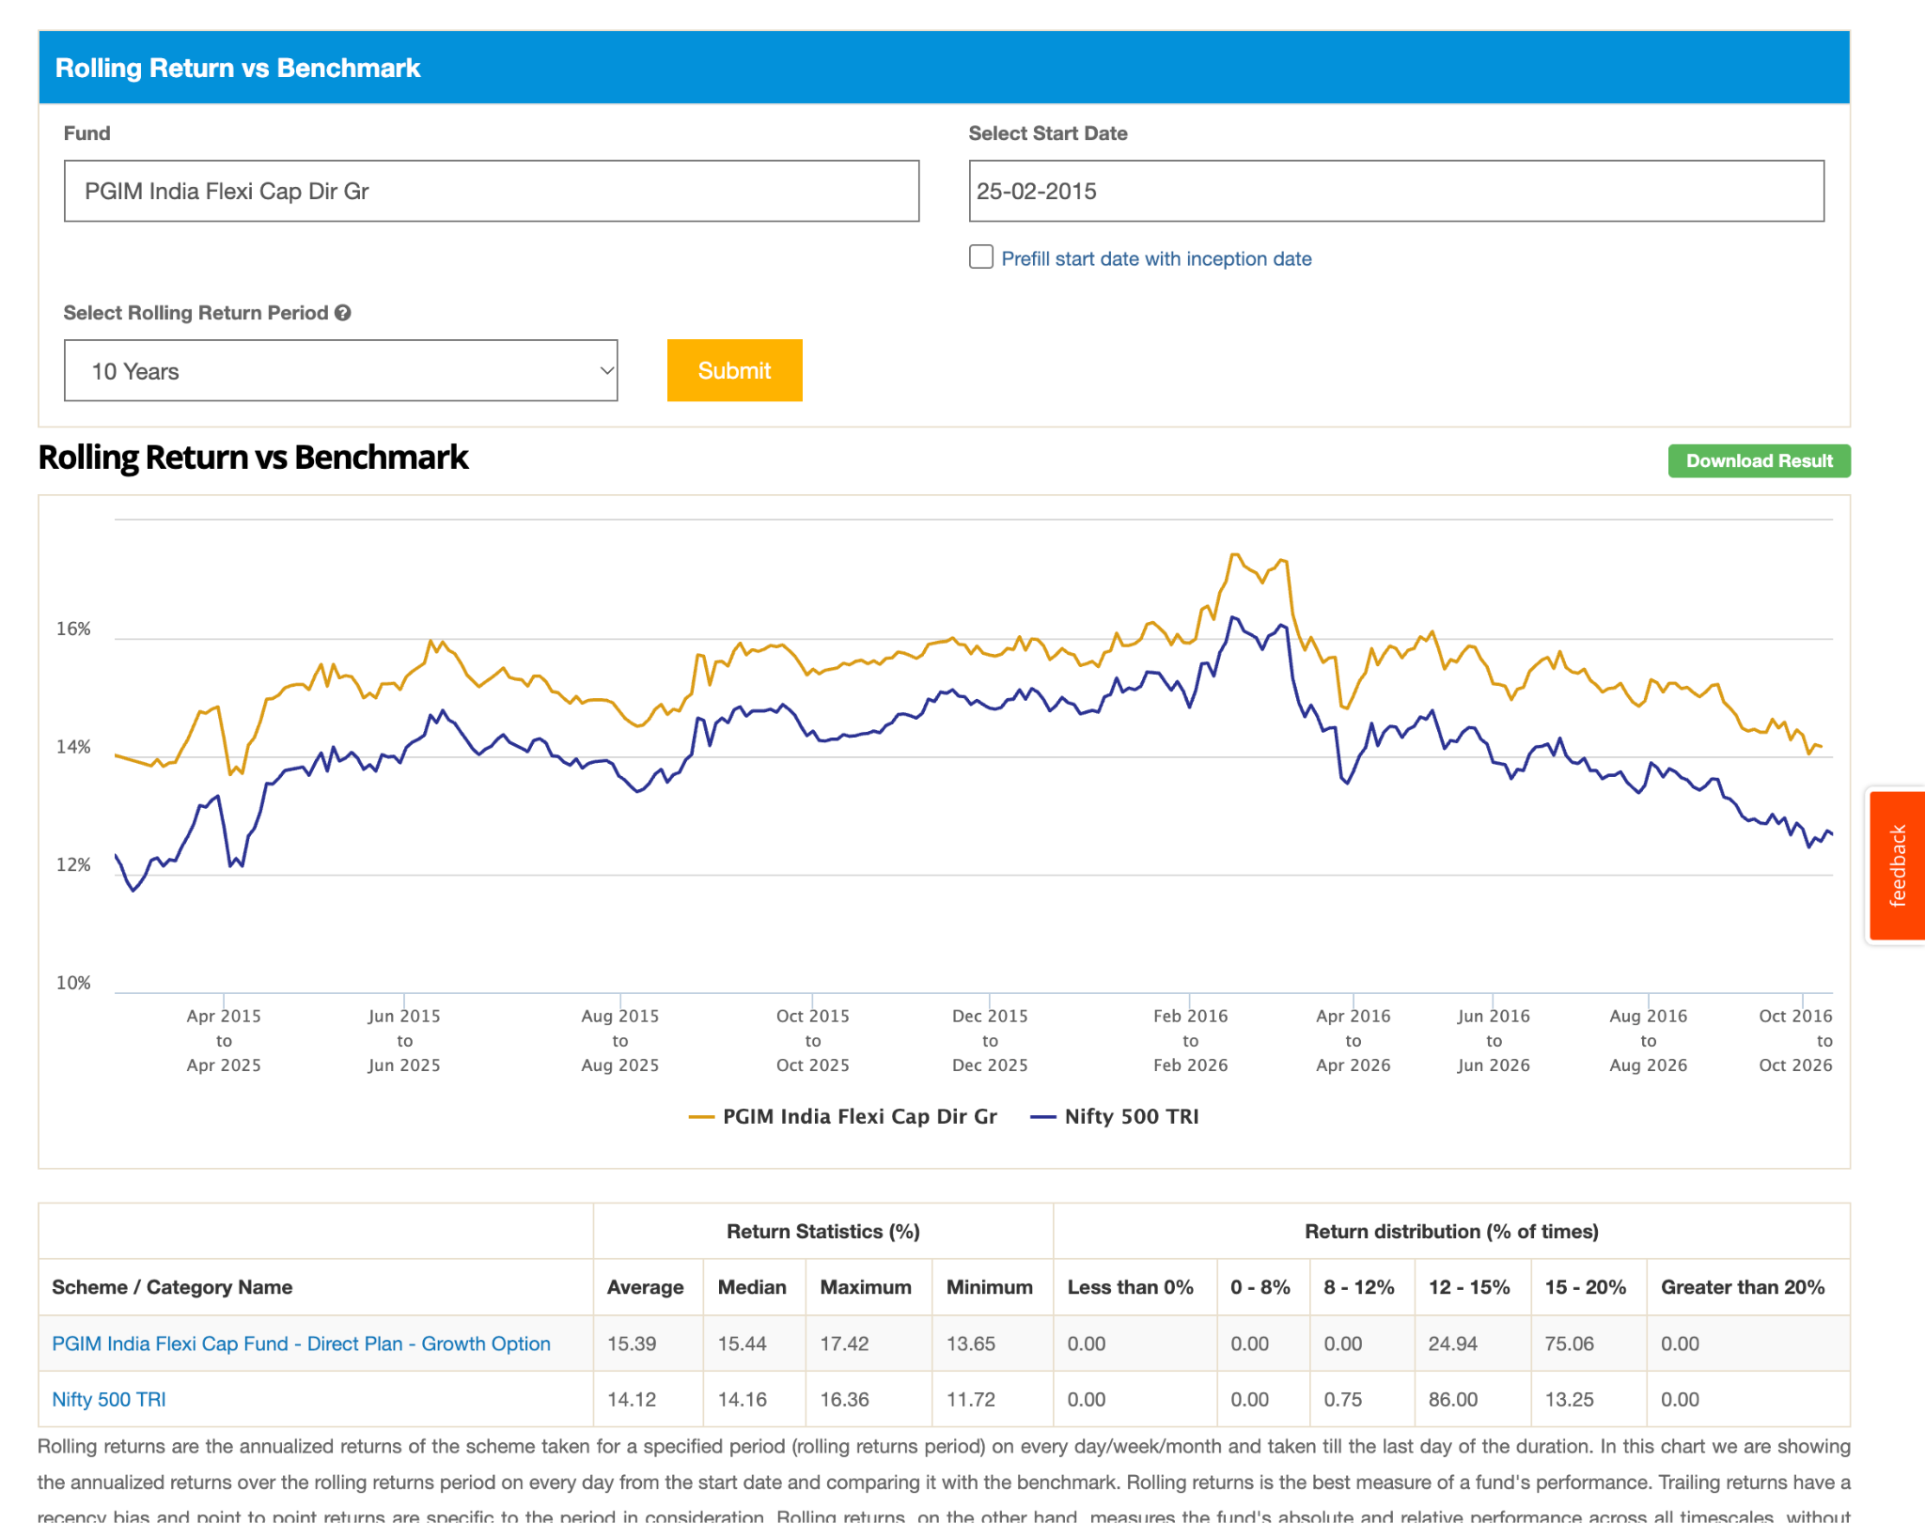
- Invesco India Flexi Cap Dir, 5.5k, 5y, 0.53%, 4*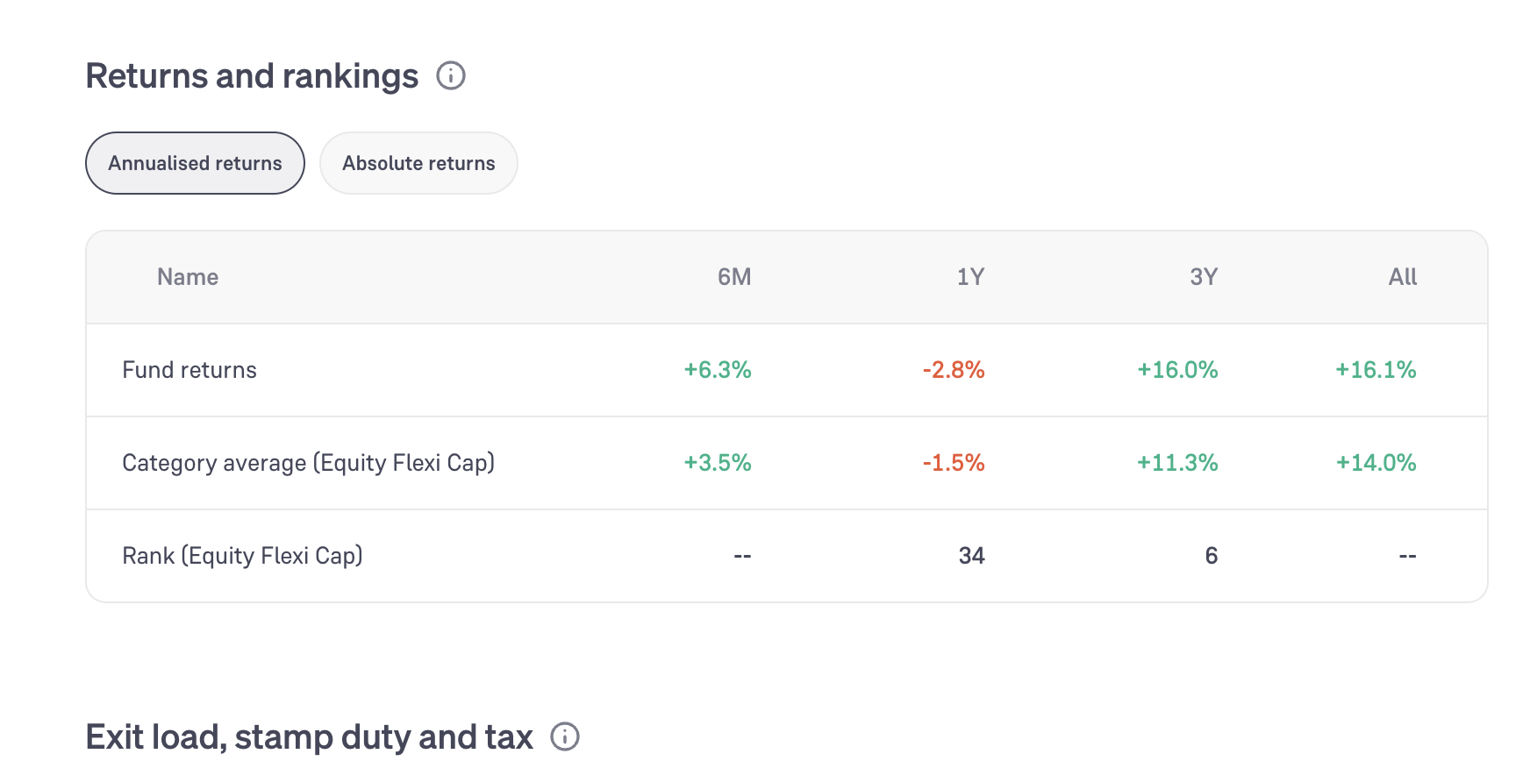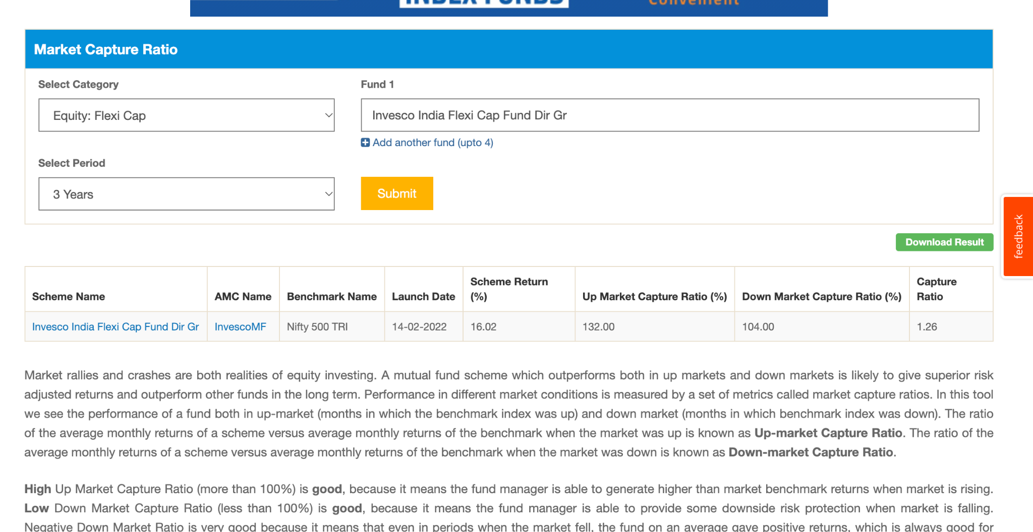
- JM Flexi Cap Dir, 5k , 14k, 0.56% , 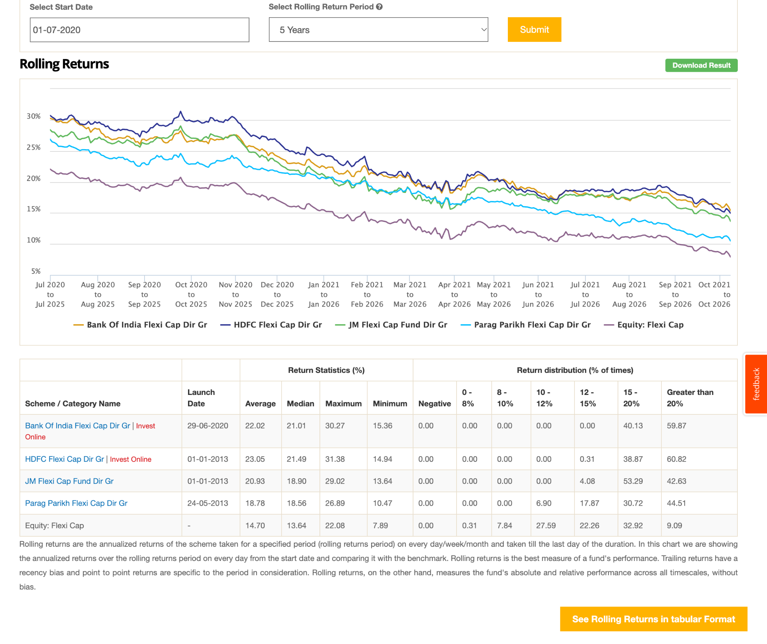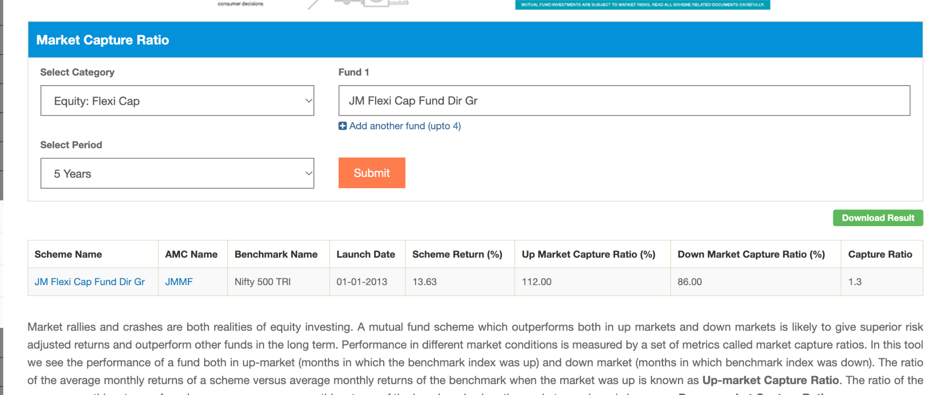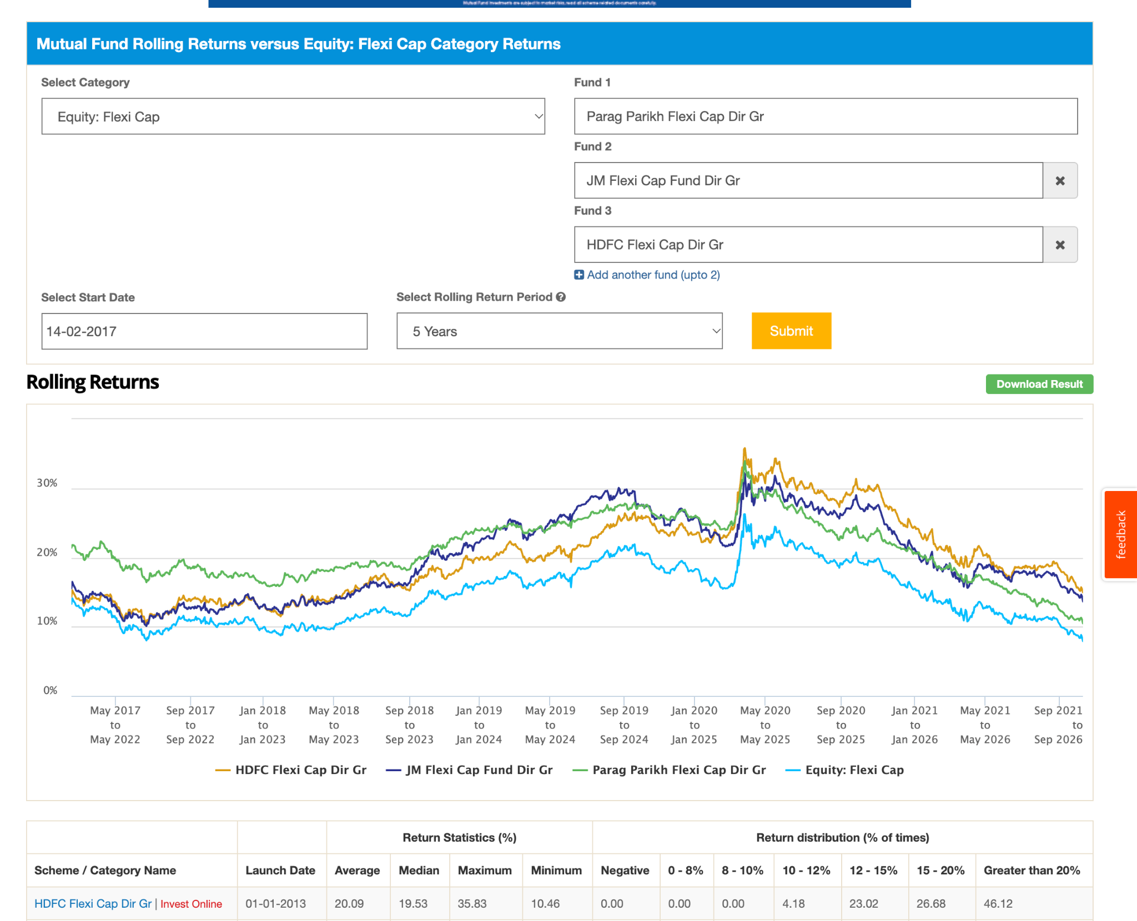
- Mirae Asset Flexi Cap Dir, 4.3k, 3y, 0.46%, 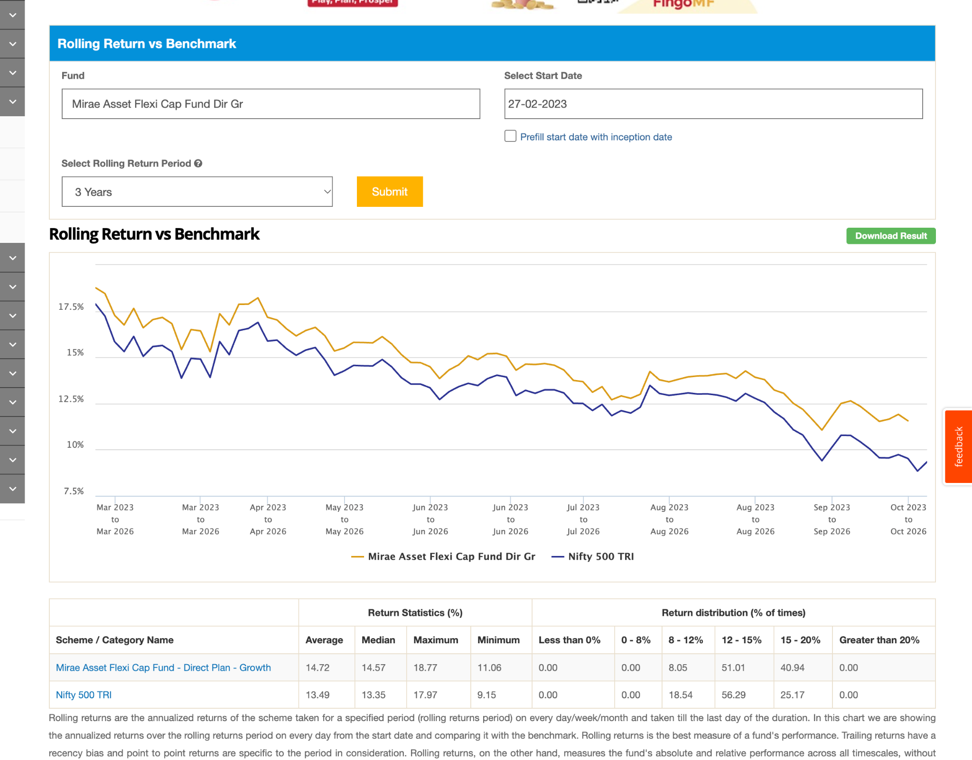
- Edelweiss Flexi Cap Dir, 11y 3.5k , 0.46, long term > 3y beating good
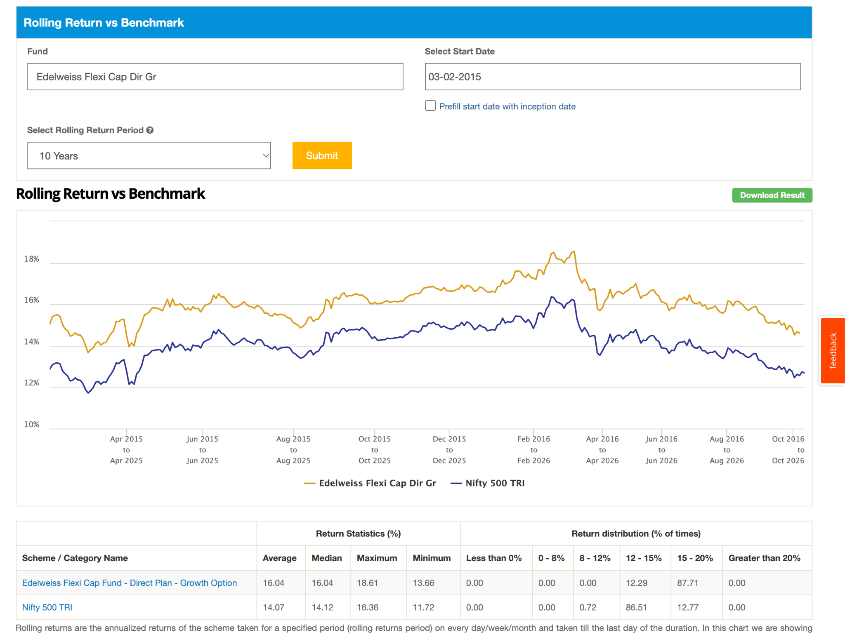
- Tata Flexi Cap Dir, 8y, 0.6%, 3.5k
- JioBlackRock Flexi Cap Dir, 1y 3.2k, 0.5%,
- Bank of India Flexi Cap Dir, 3k , 6y, 0.48, 5*, great performance f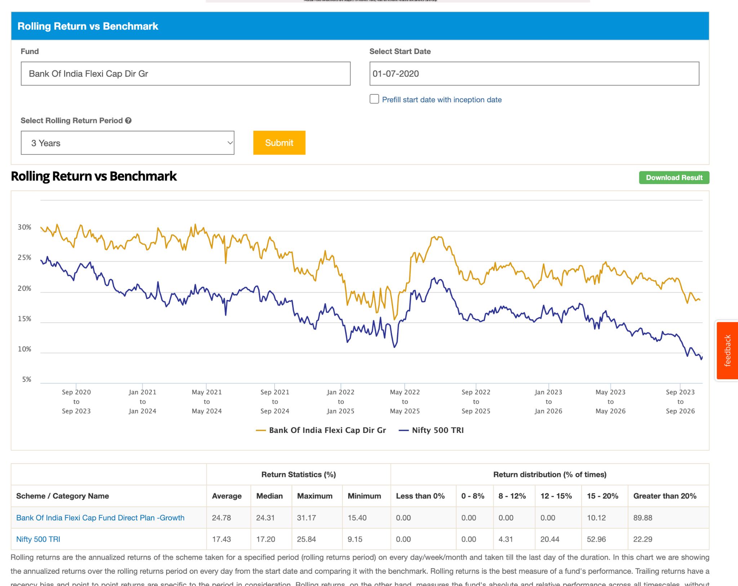return event better than iti flexi cap fund manager alok singh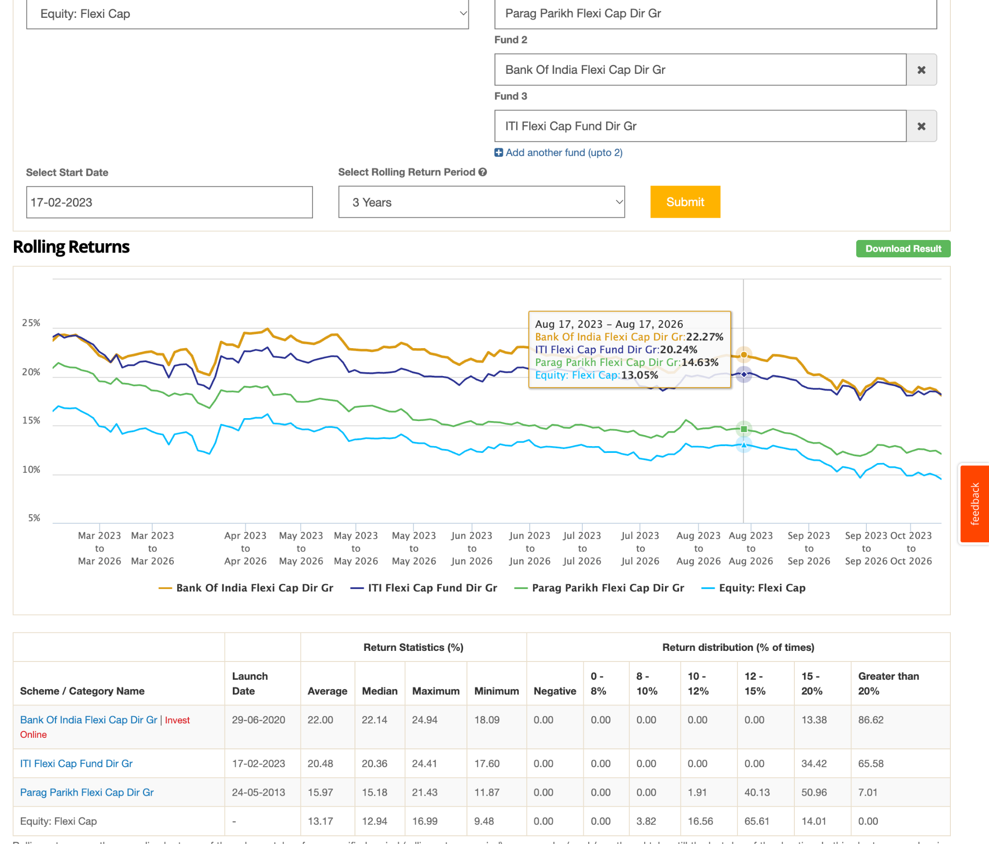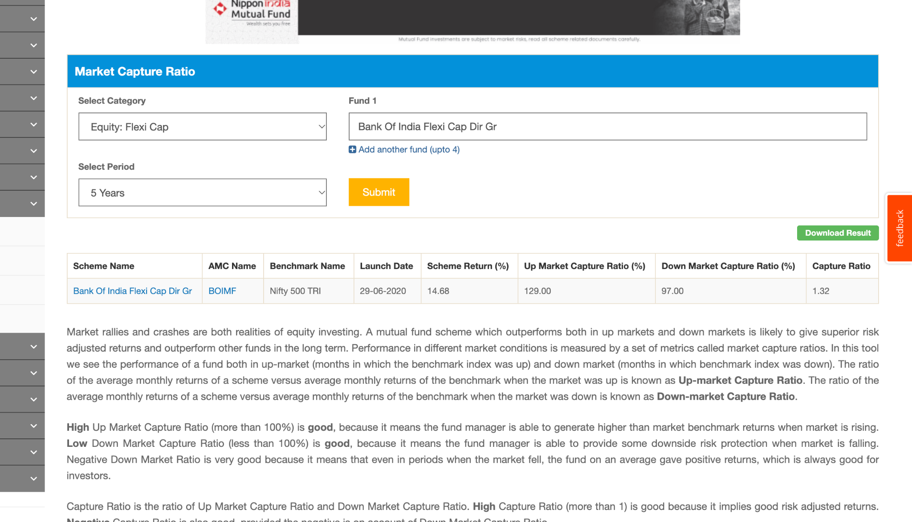
- NJ Flexi Cap Dir, 3y 2.5k, 0.52,
- Union Flexi Cap Dir, 13y 2.3k , 0.84 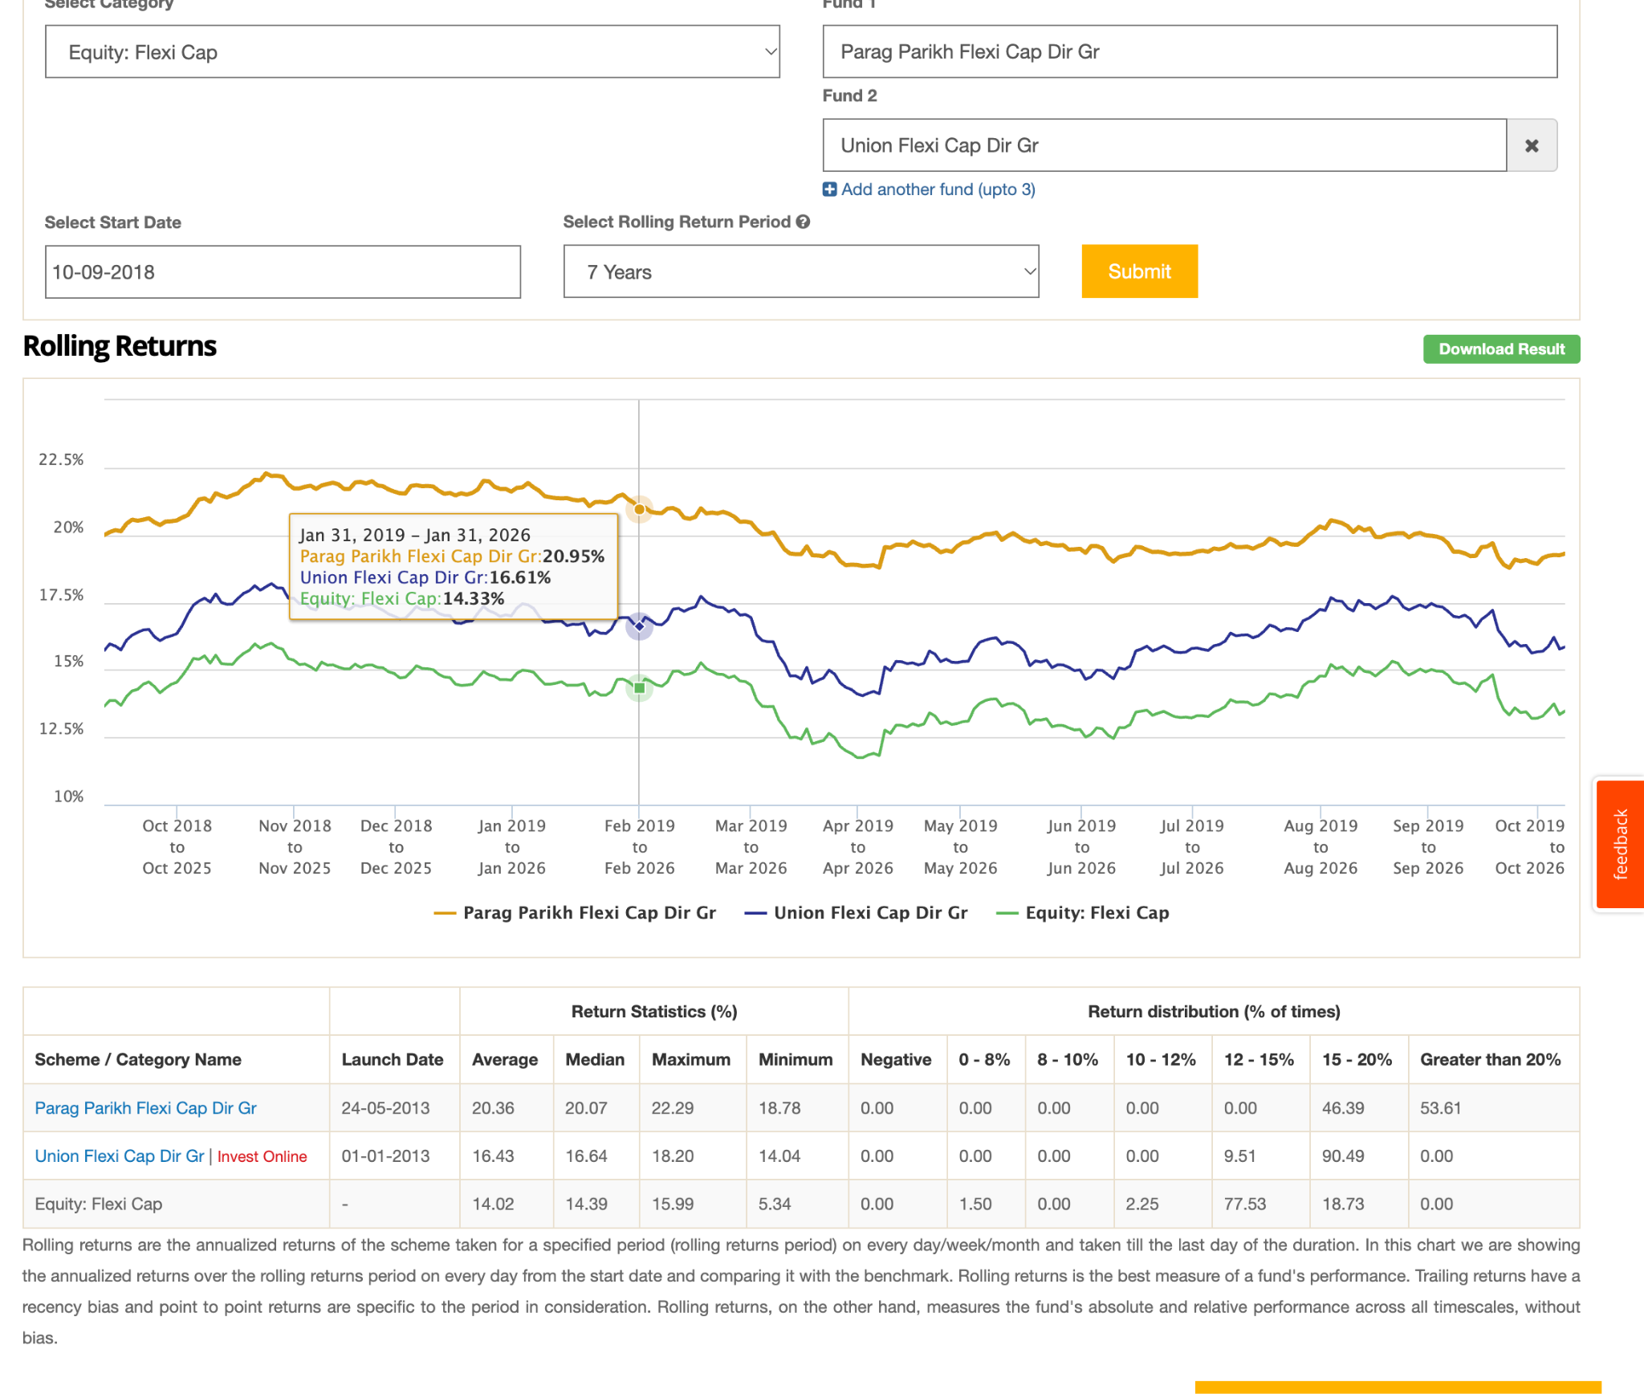
- 360 ONE Flexicap Dir , 2.1k, 3y, 0.5% 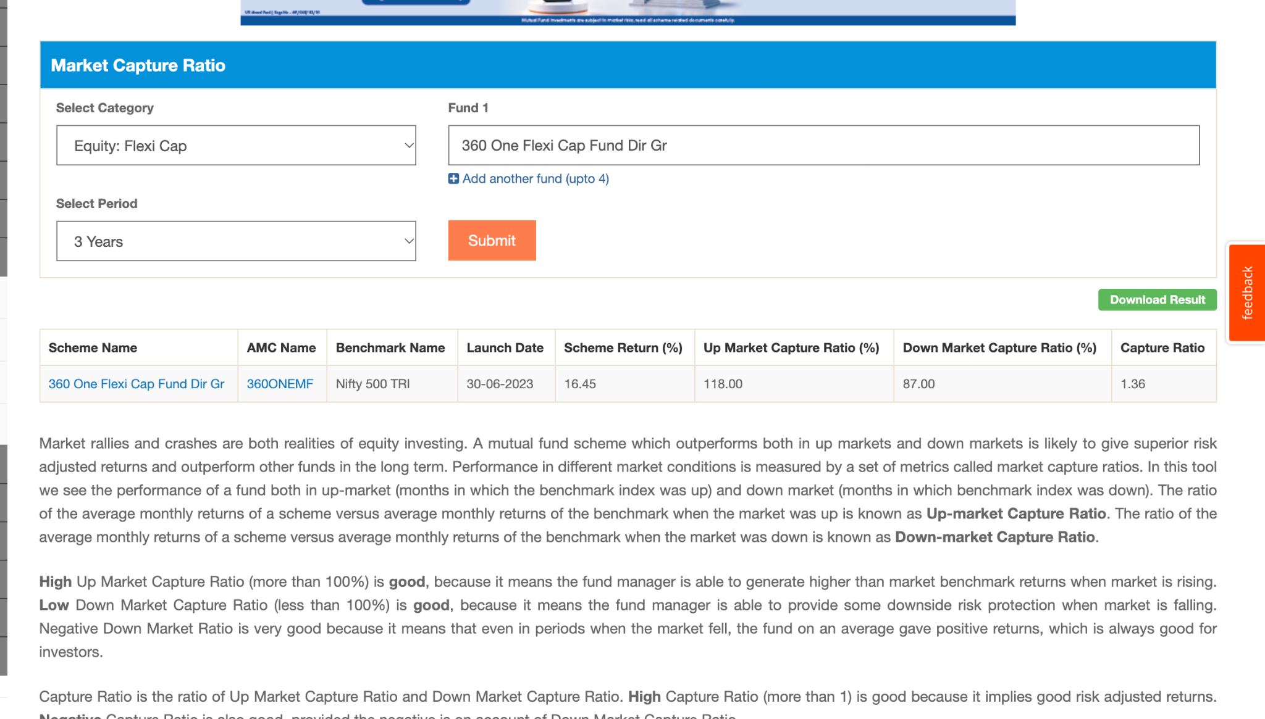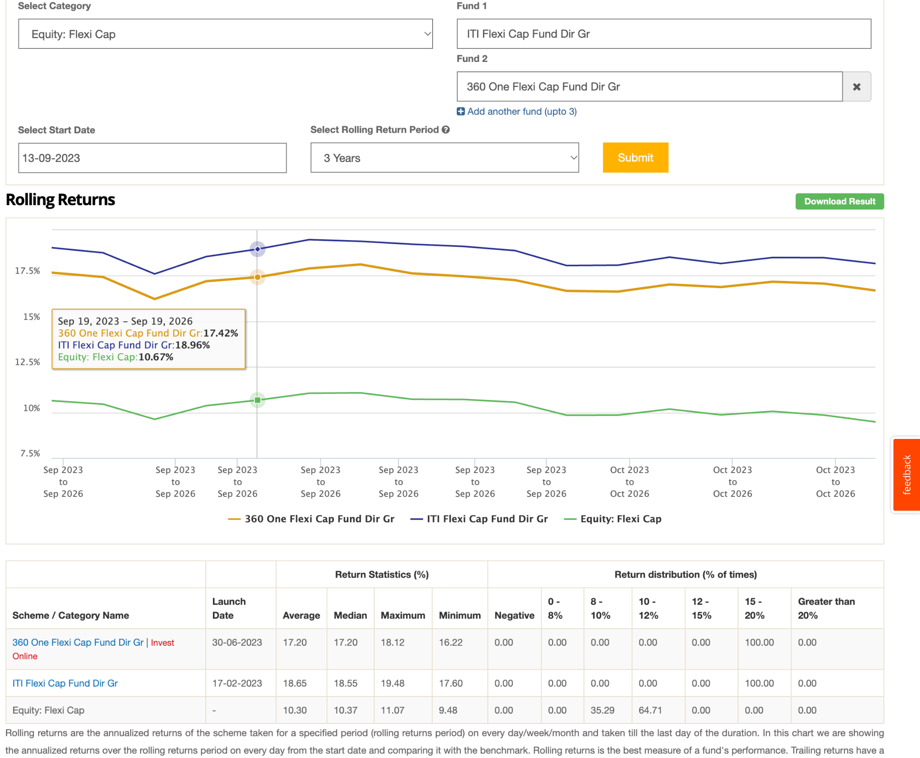
- Sundaram Flexi Cap Dir, 4y 1.8k , 0.63, 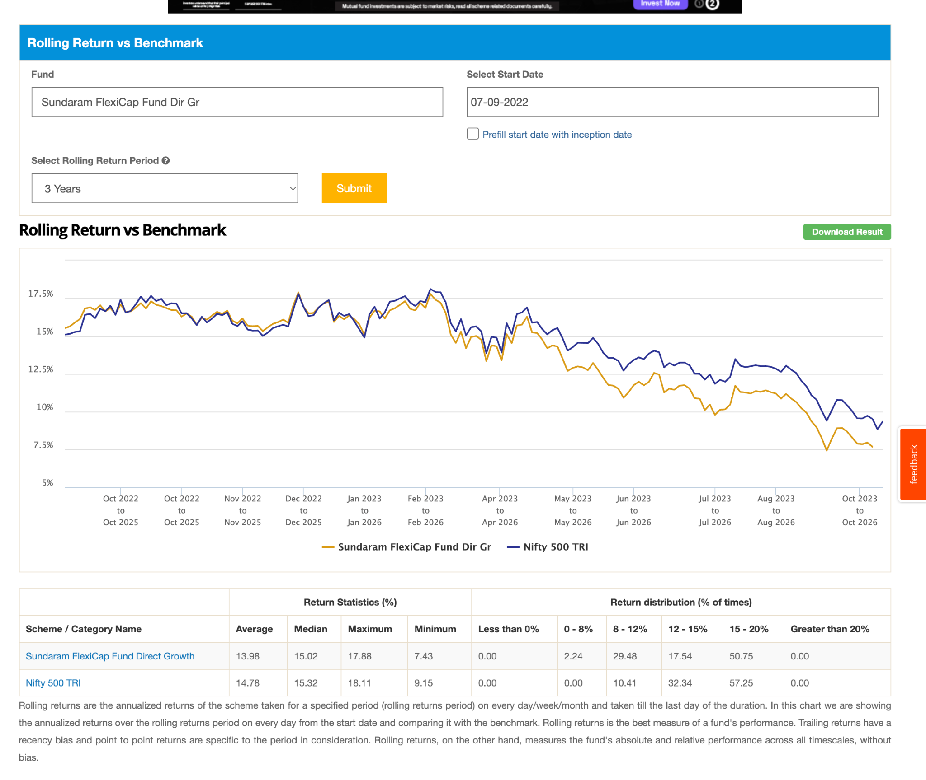
- Mahindra Manulife Flexi Cap Dir, 5y 1.5k, 0.51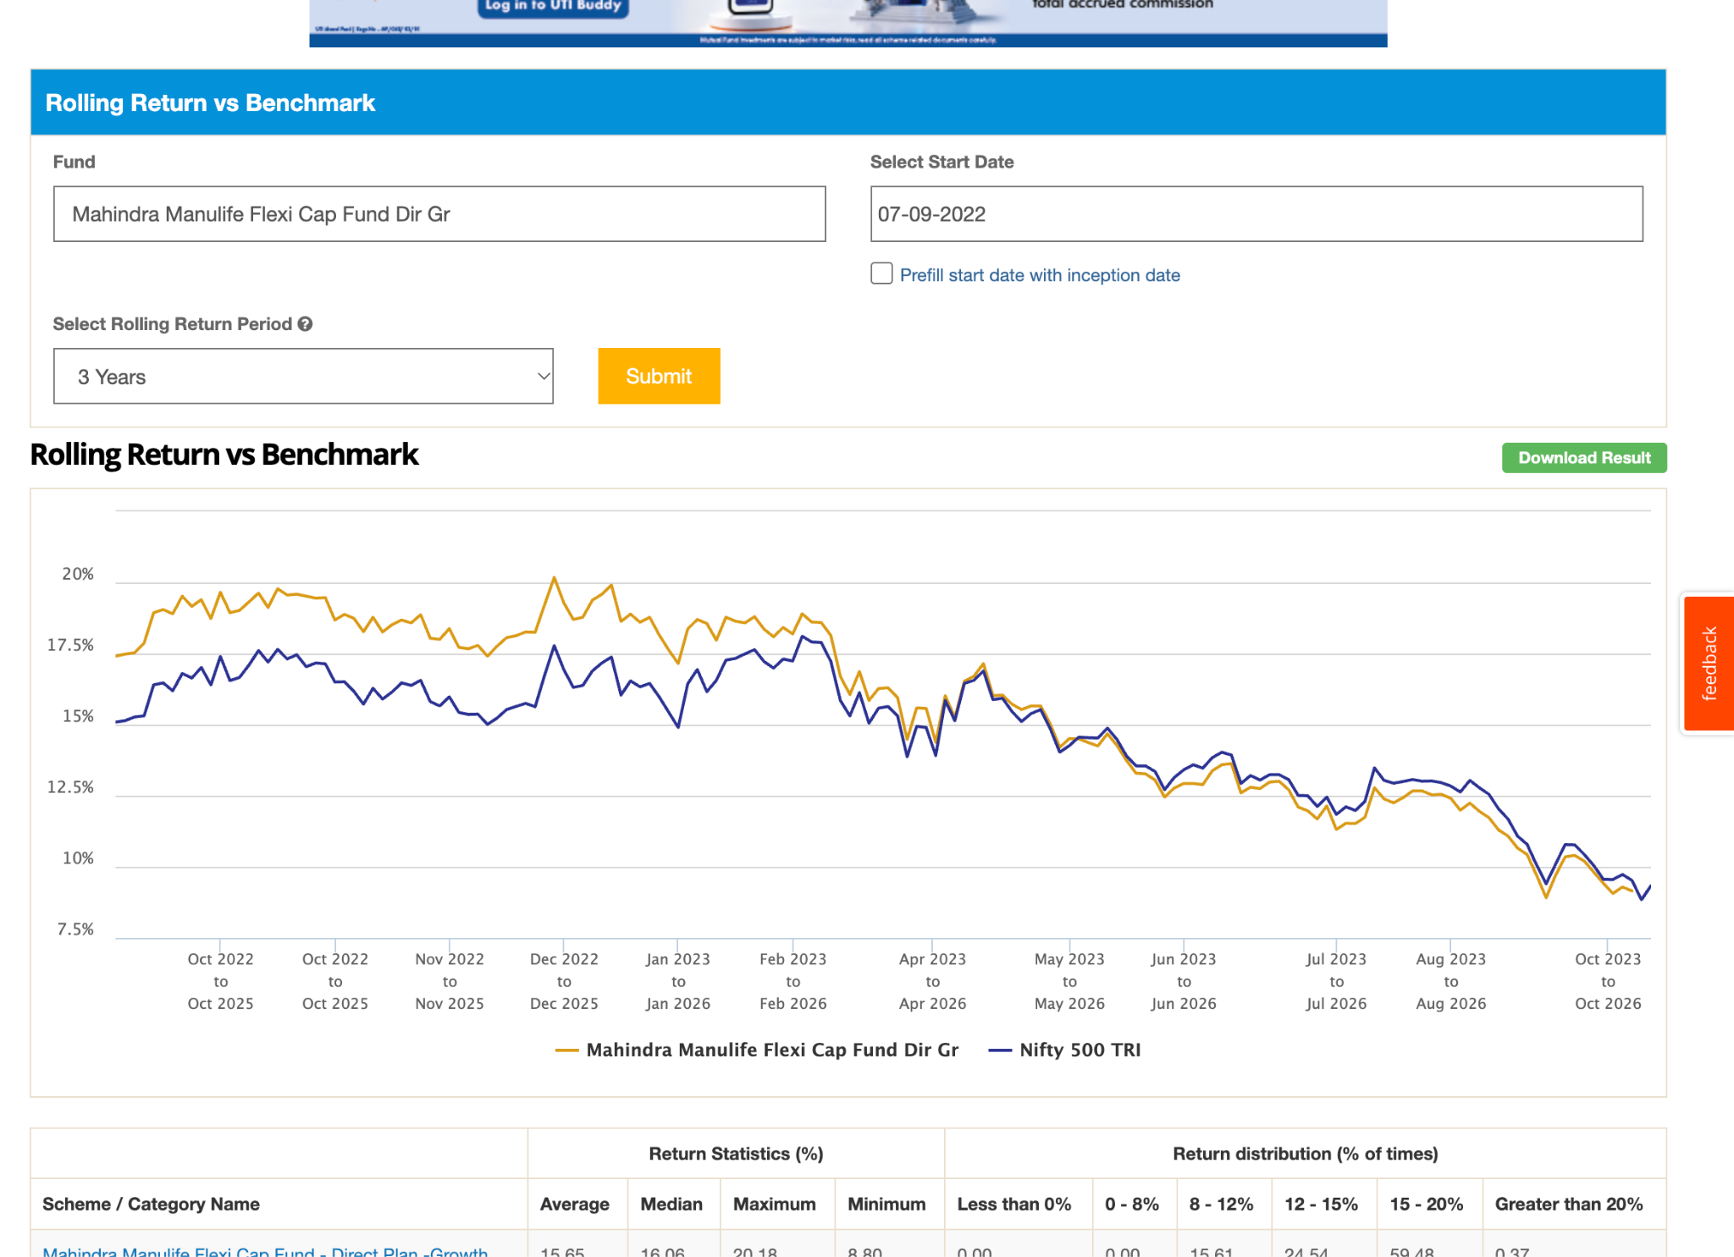
- ITI Flexi Cap Dir , 4y 1.6k, great returns , 5*, 0.53%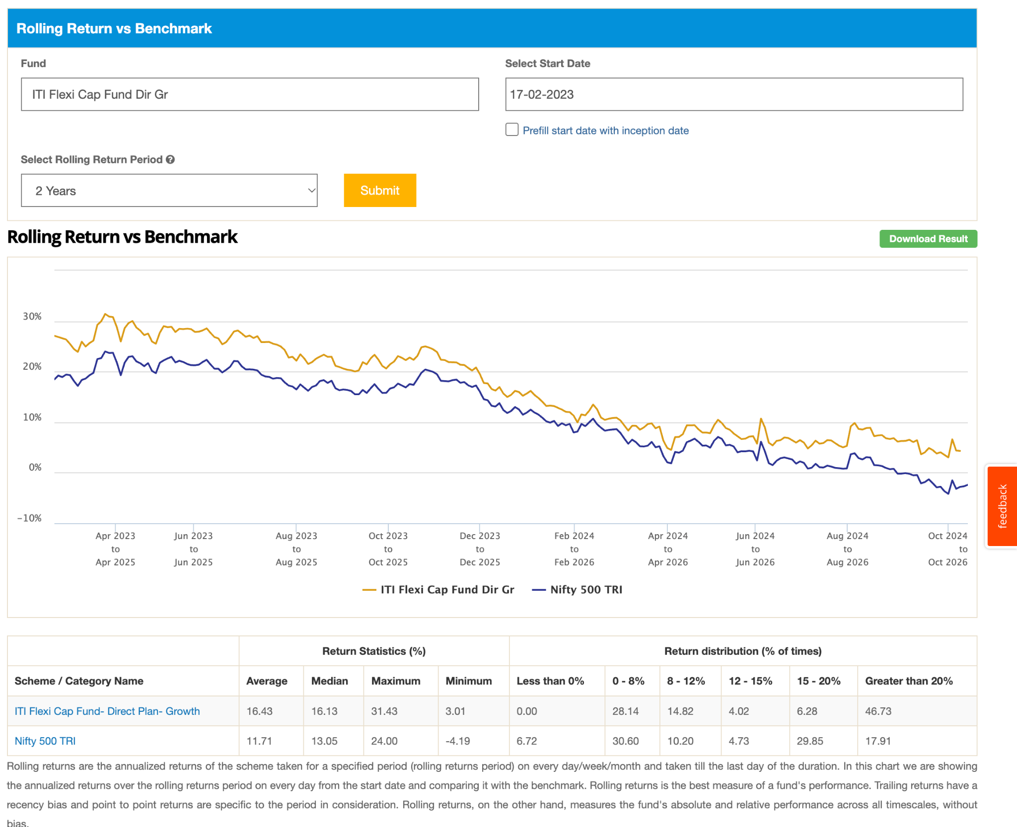
- Baroda BNP Paribas Flexi Cap Dir: 4y , 1k
- LIC MF Flexi Cap Dir , 1k , 13Y
- TRUST MF Flexi Cap Dir: 2y 1k, good ranking single digit in comparition.
- Capitalmind Flexi Cap Dir
- Navi Flexi Cap Dir 8y 250 cr.
- Old Bridge Flexi Cap Dir, 7m 451cr
- Quantum Flexi Cap Dir: 2month ignore.
- Samco Flexi Cap Dir , 4y, 250crore
- Shriram Flexi Cap Dir: 8y but only 122 crore ignore
- Taurus Flexi Cap Dir 13y, 350 cre
- The Wealth Company Flexi Cap Dir, 1y 239
- Unifi Flexi Cap Dir , 1y old 239 crore ignore for now.
- AlphaGrep Flexi Cap Dir: 2 month very new ignore

One thing is clear , they most are beating the 500, its just that who is generating alpha most are beating , some are generating great alpha.
also major have same pattern , but some somehow generating alpha lot more other not.

green:
- hdfc finance heavey: 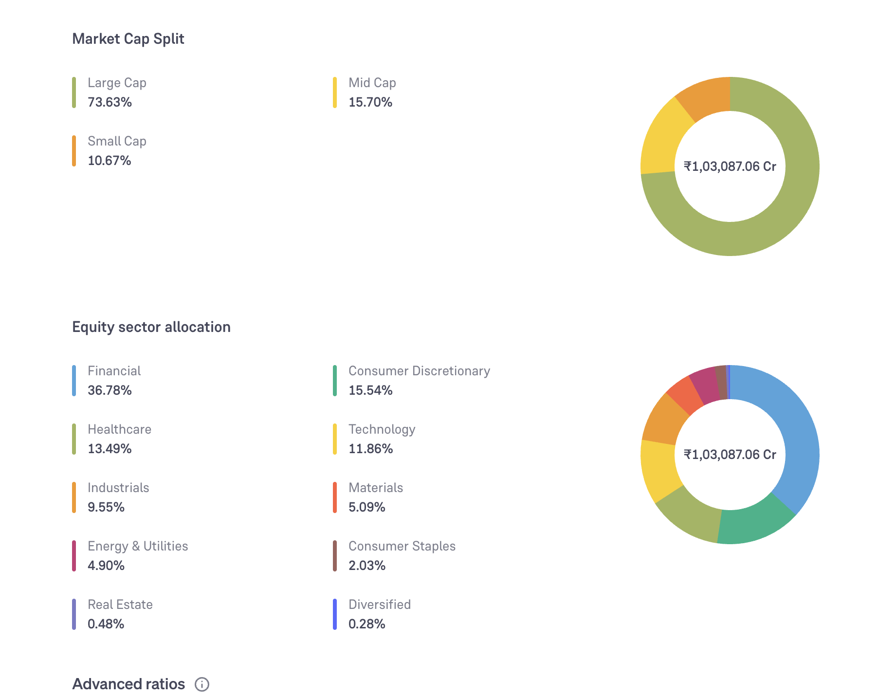
- parag : finance , tech:
- quant -> concentrated , high volatile , energy heave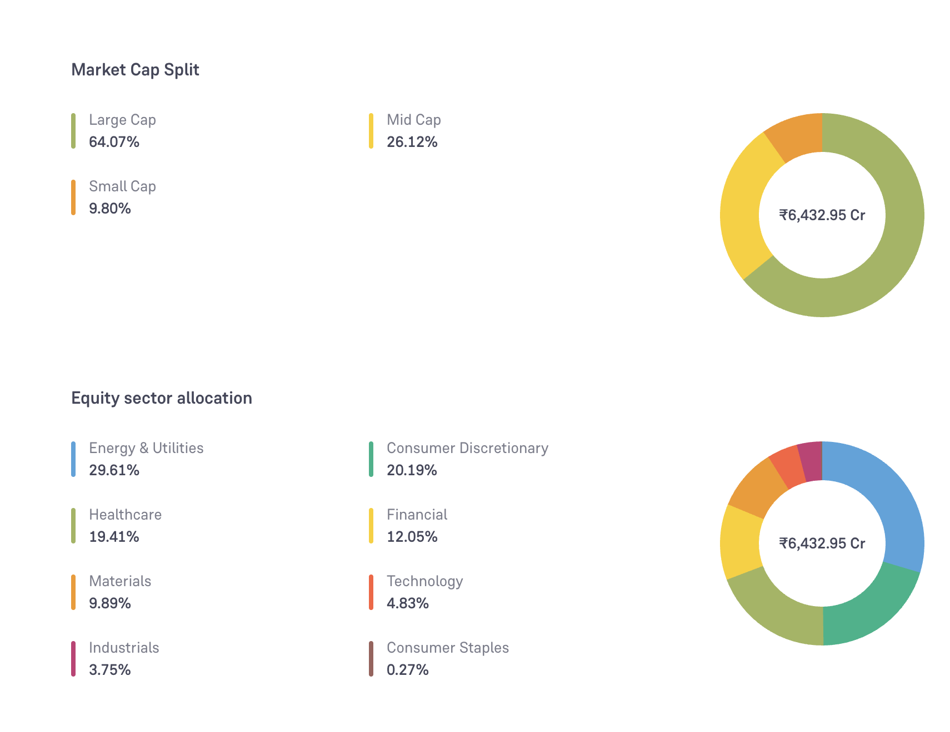
- icici, 5y , consuerm heavey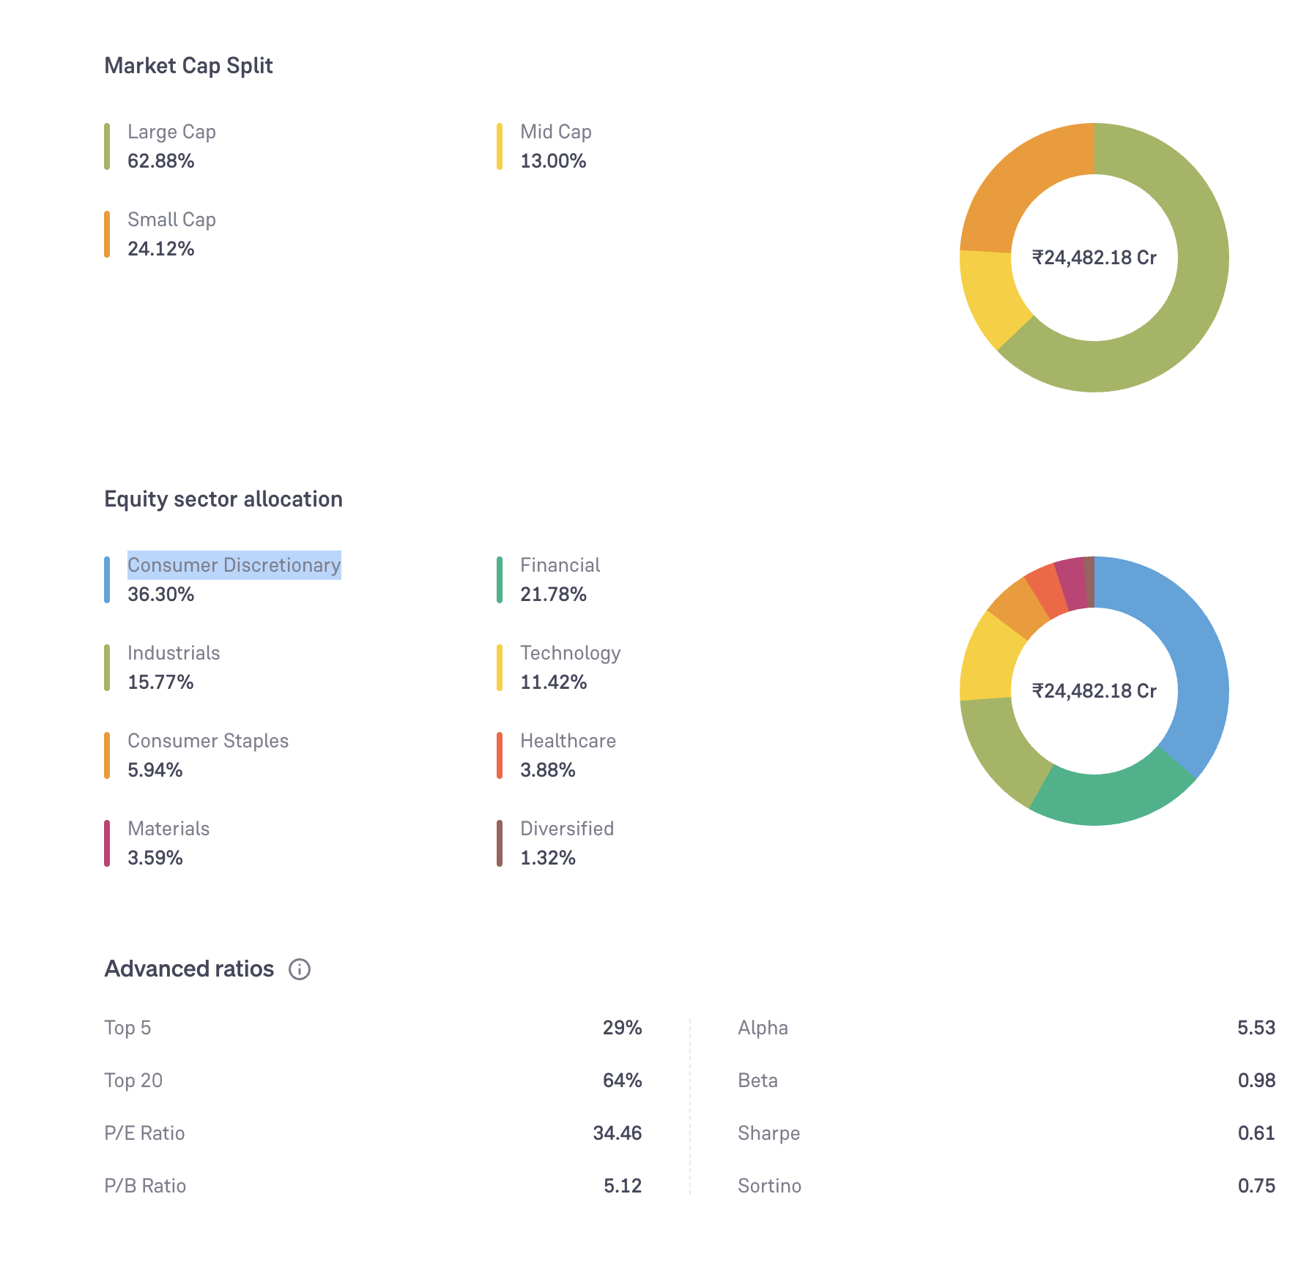
- invesco, 4y
- iti same here also they have good return coz of small mid cycle
- white oak
- Bajaj Finserv Flexi Cap D , samr
- one 360
- bank of india, good but small cap see obser
- helio
- abakkus, new wait for some time

orange good but observe new

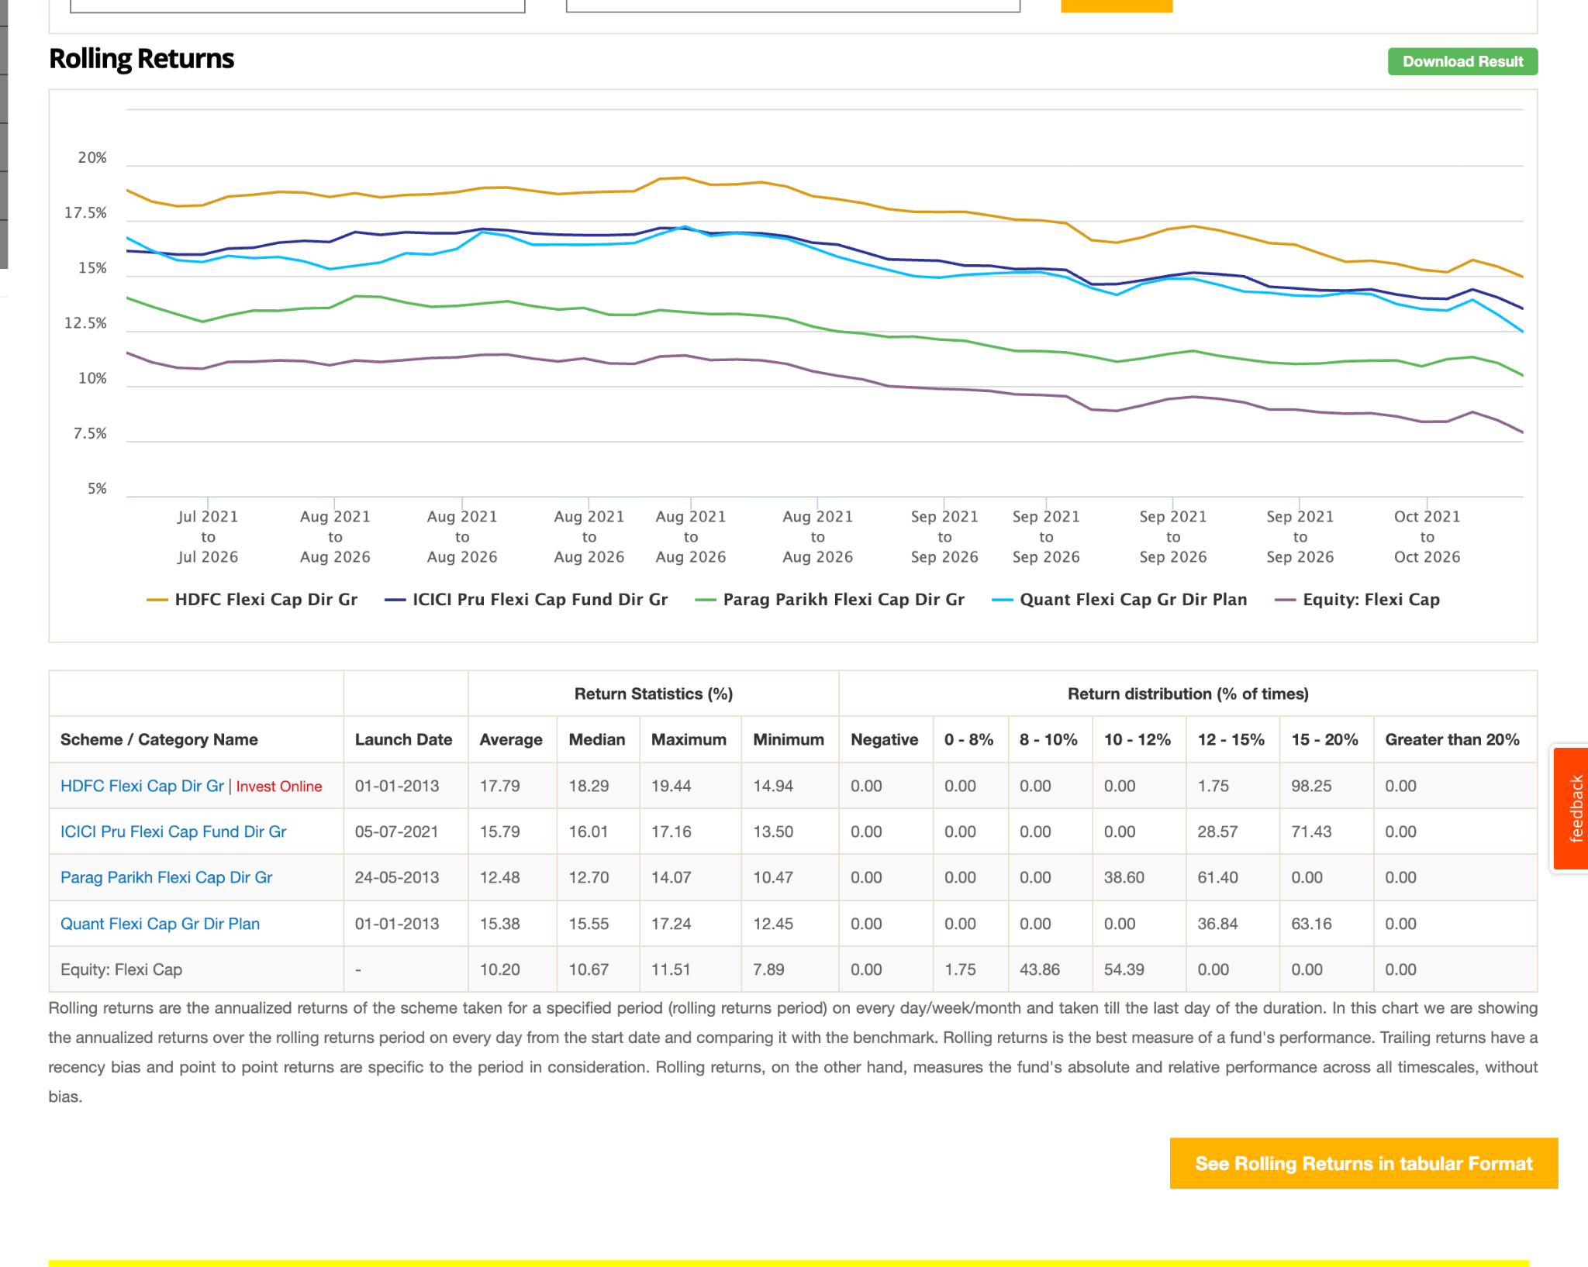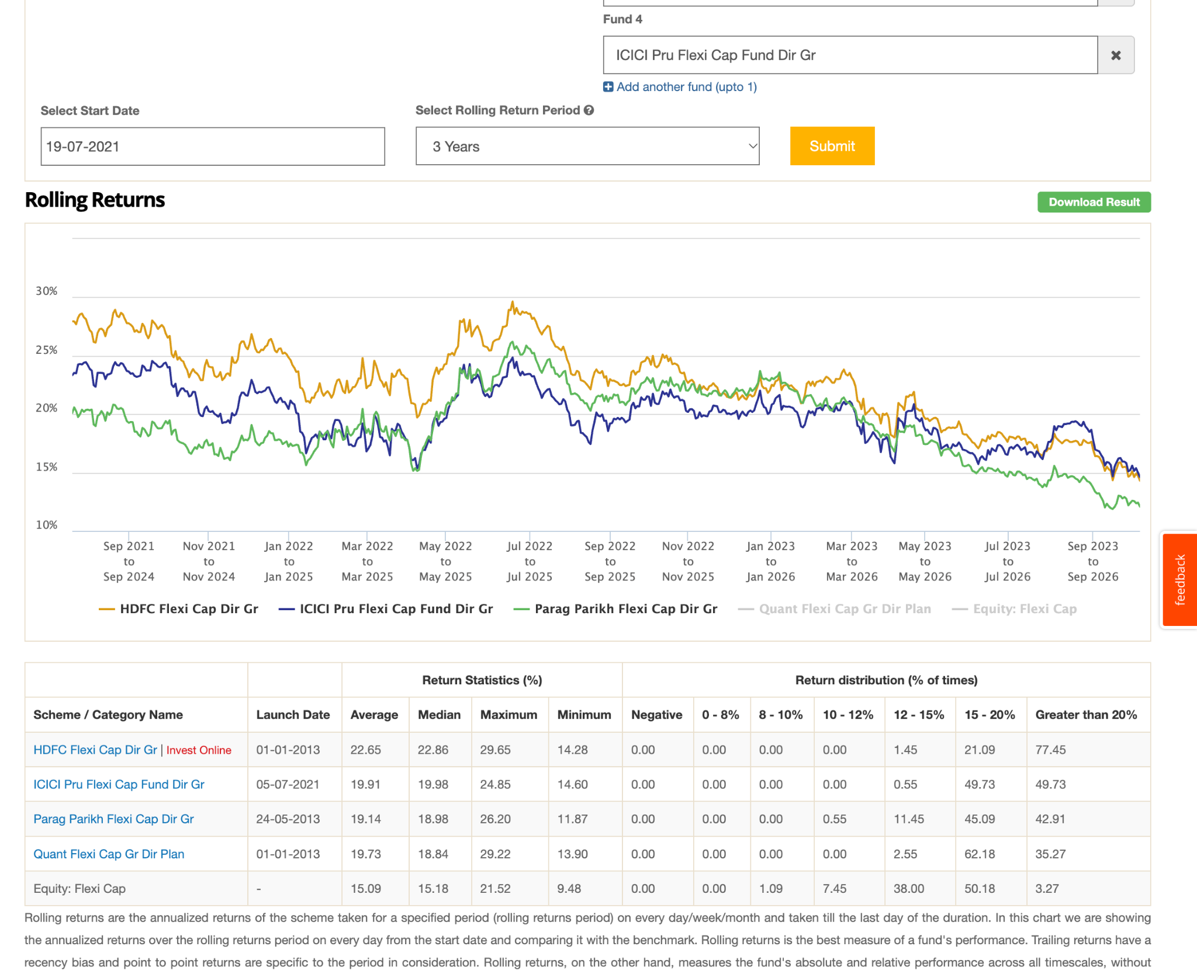

icici vs pp seems opposite some how

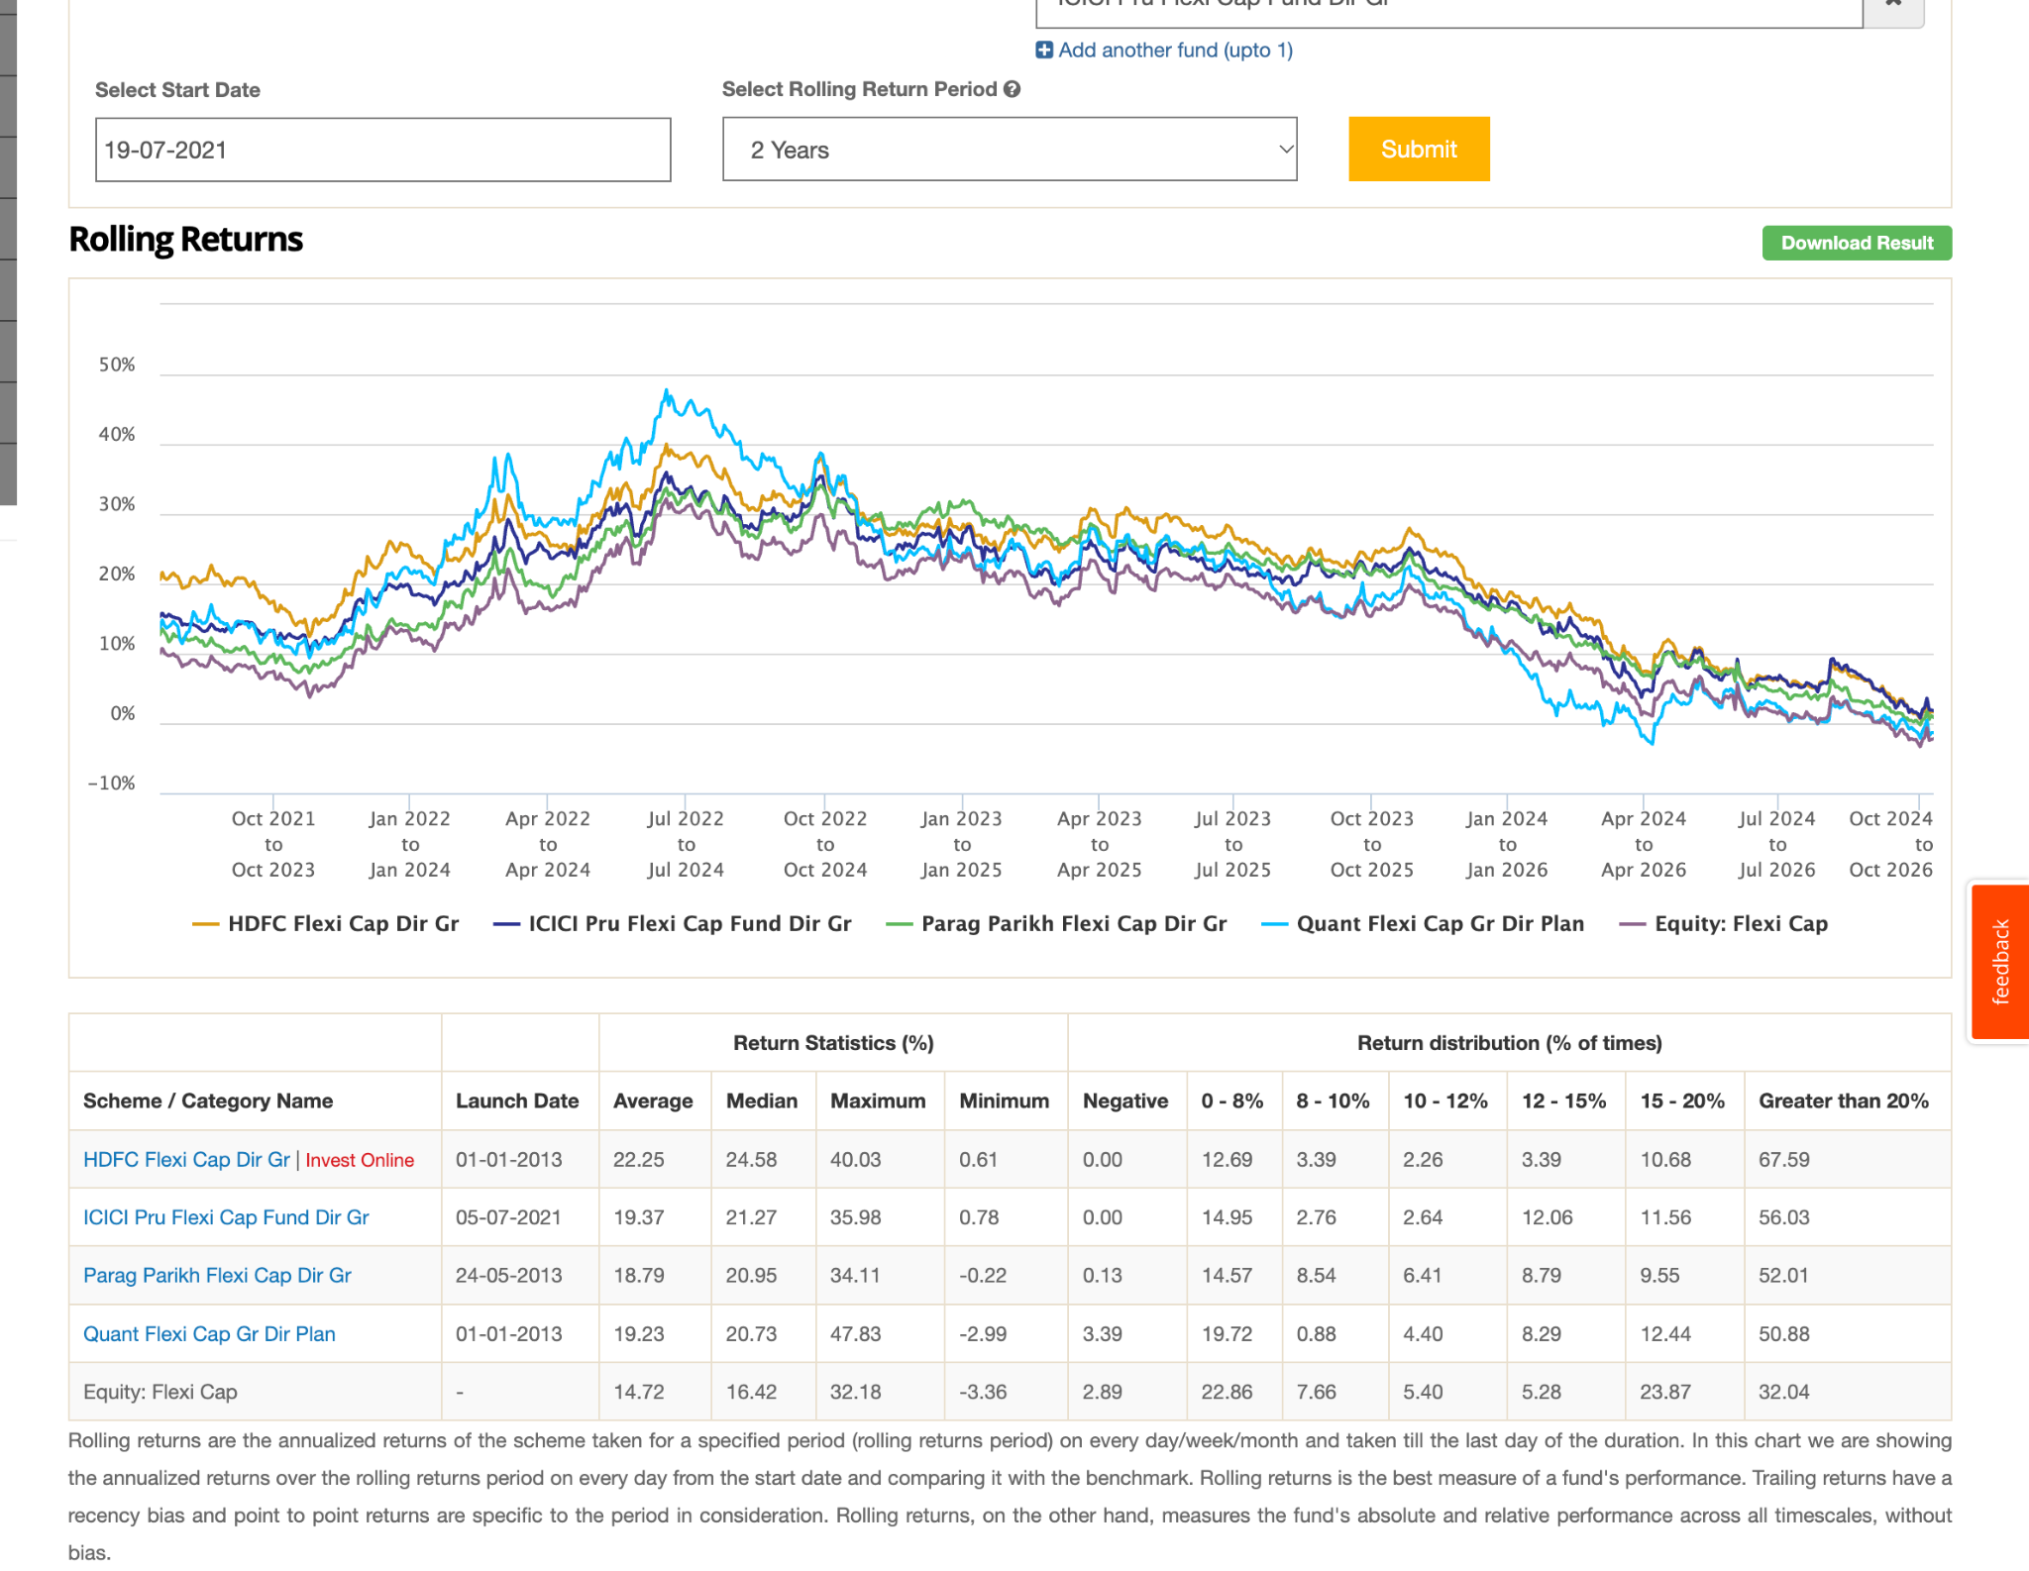

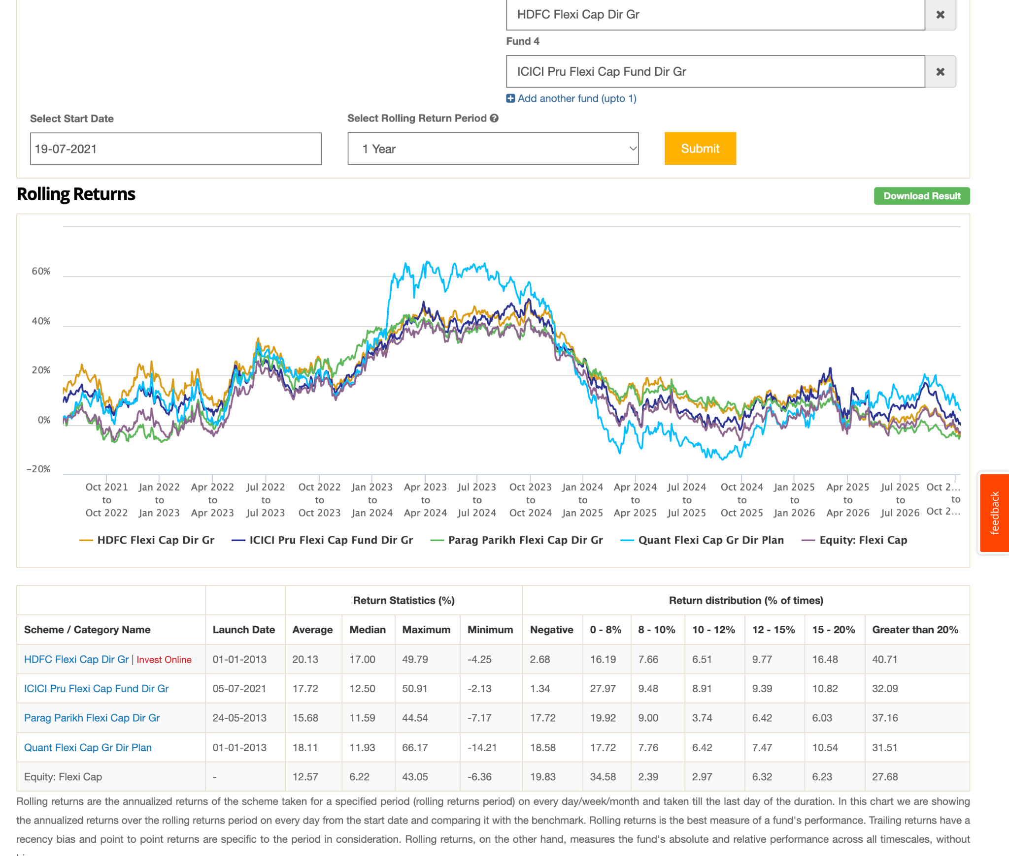

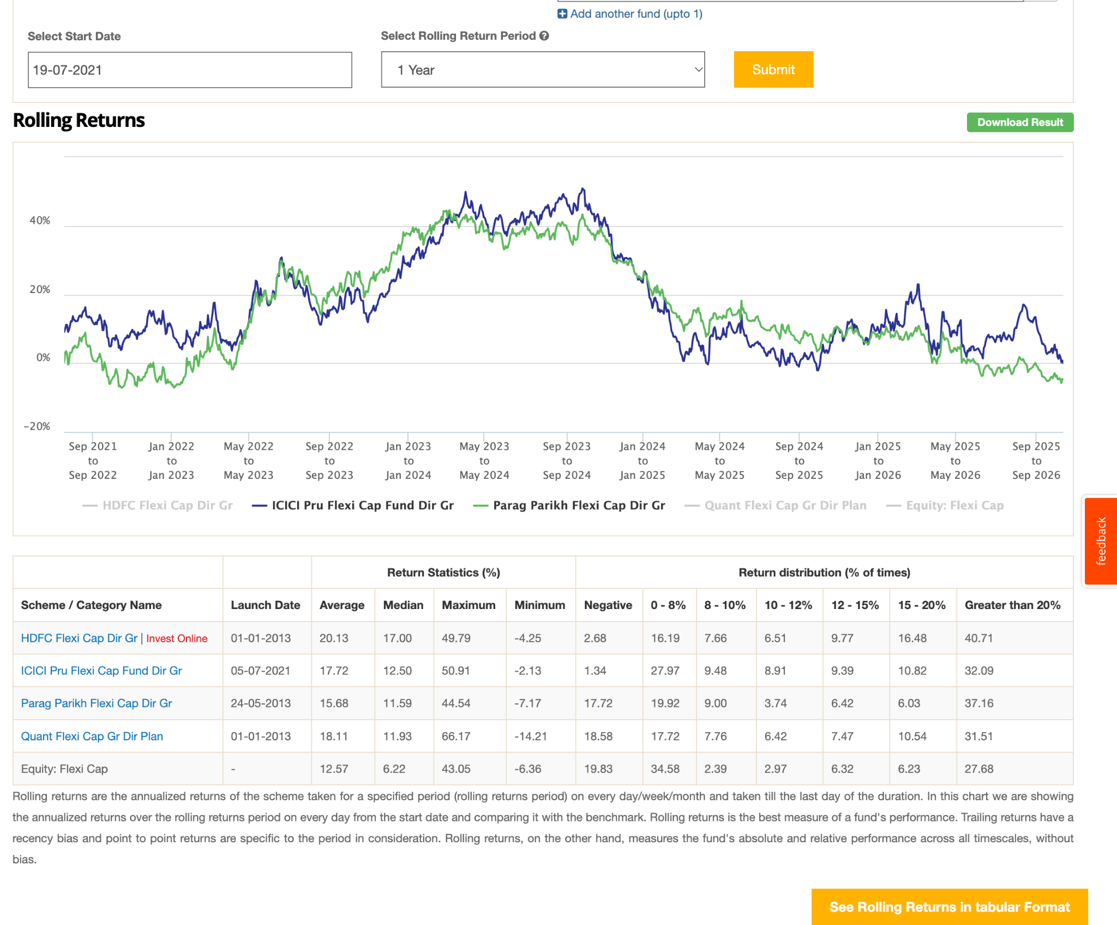

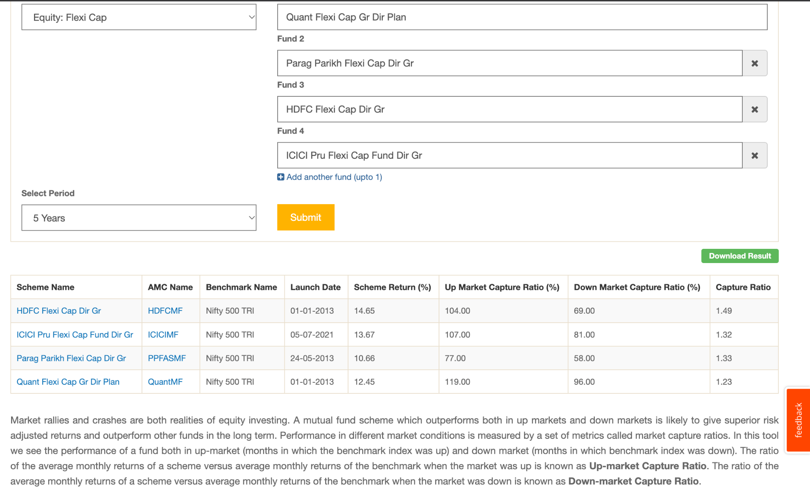

parag parikh is already selected useit as large majorly.
quant look good, also has less onverlapping, also enery heave

quant vs parag parikh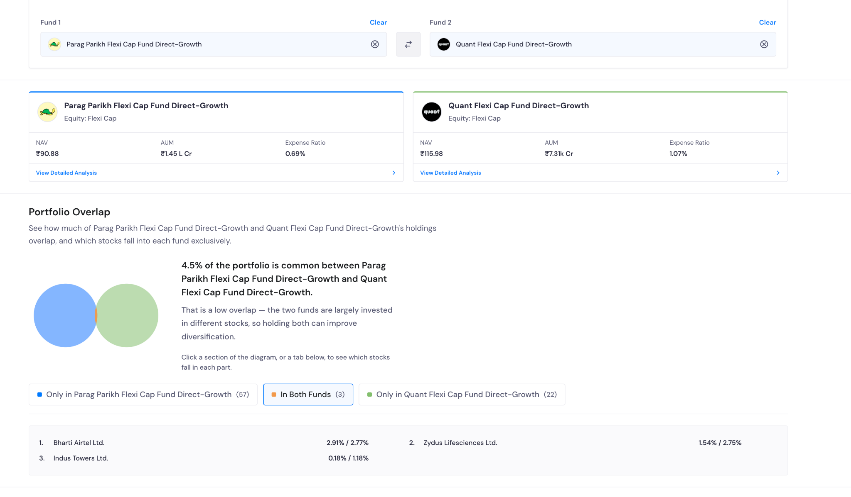
current enery utilites less: 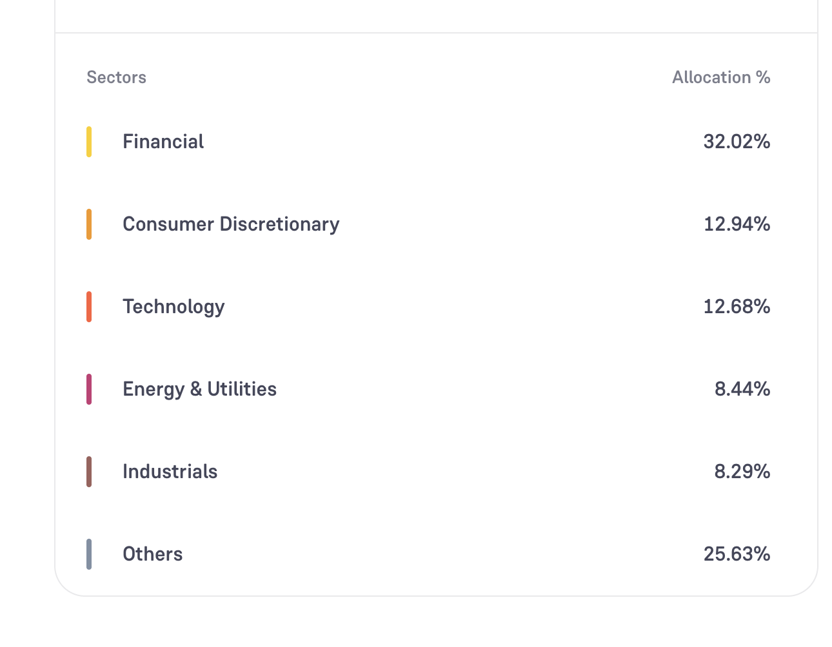
but aum quite confusing, also in 13y only 7k aum, abakkus has this in 9month :)
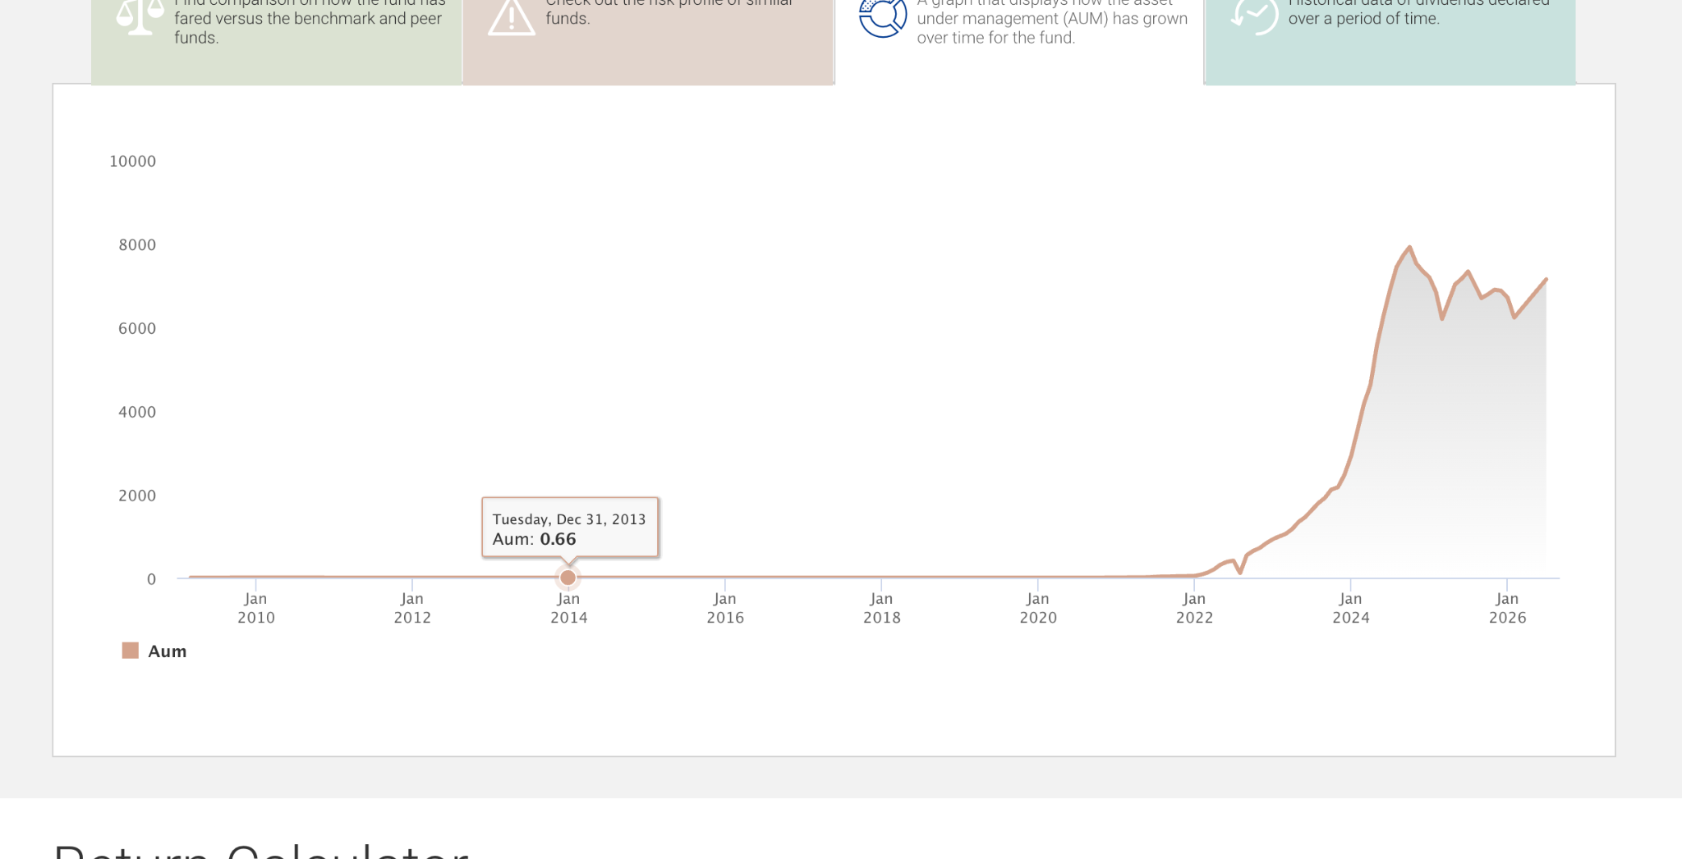
hdfc flexi cap
icici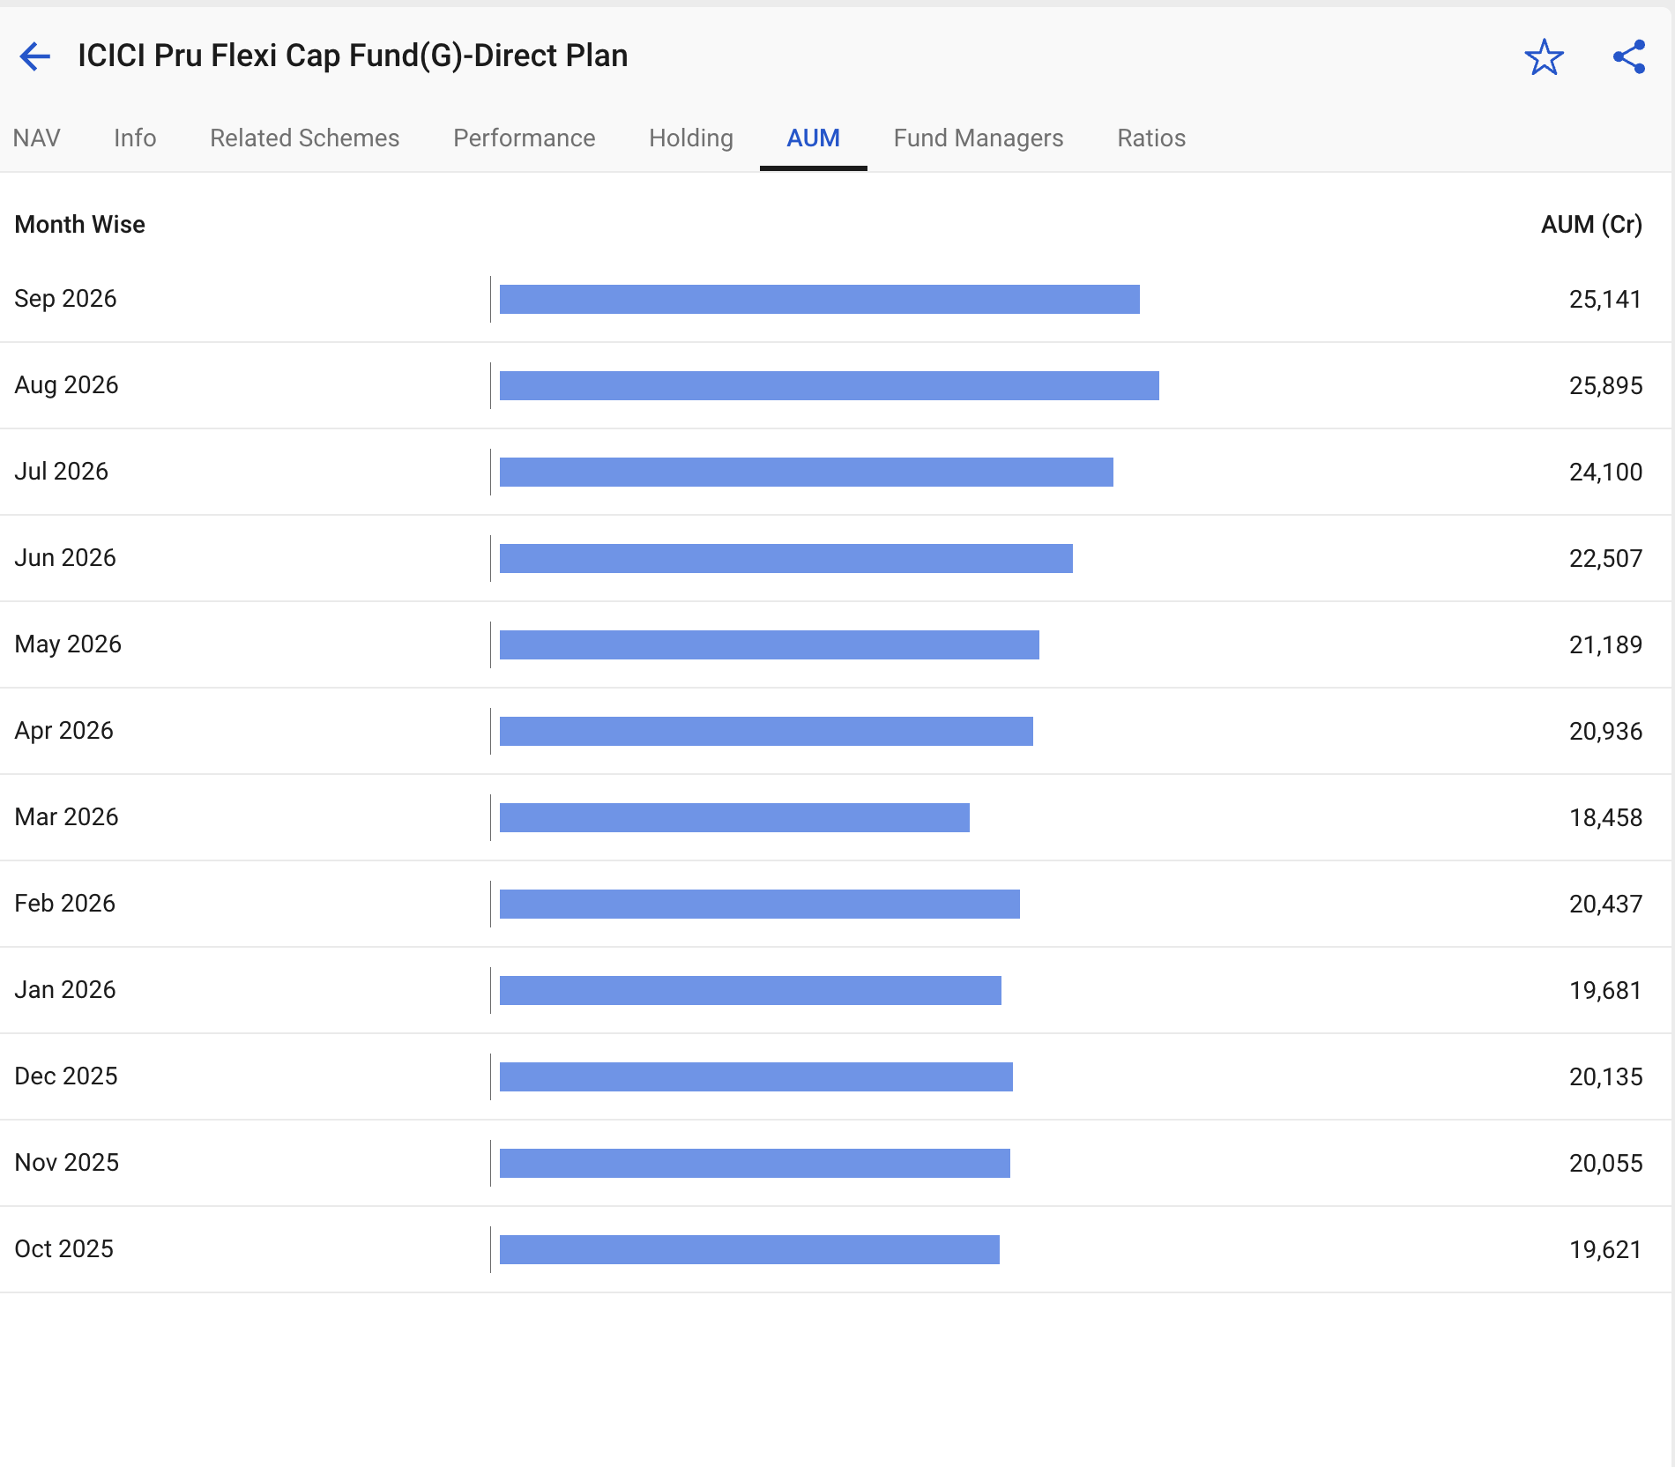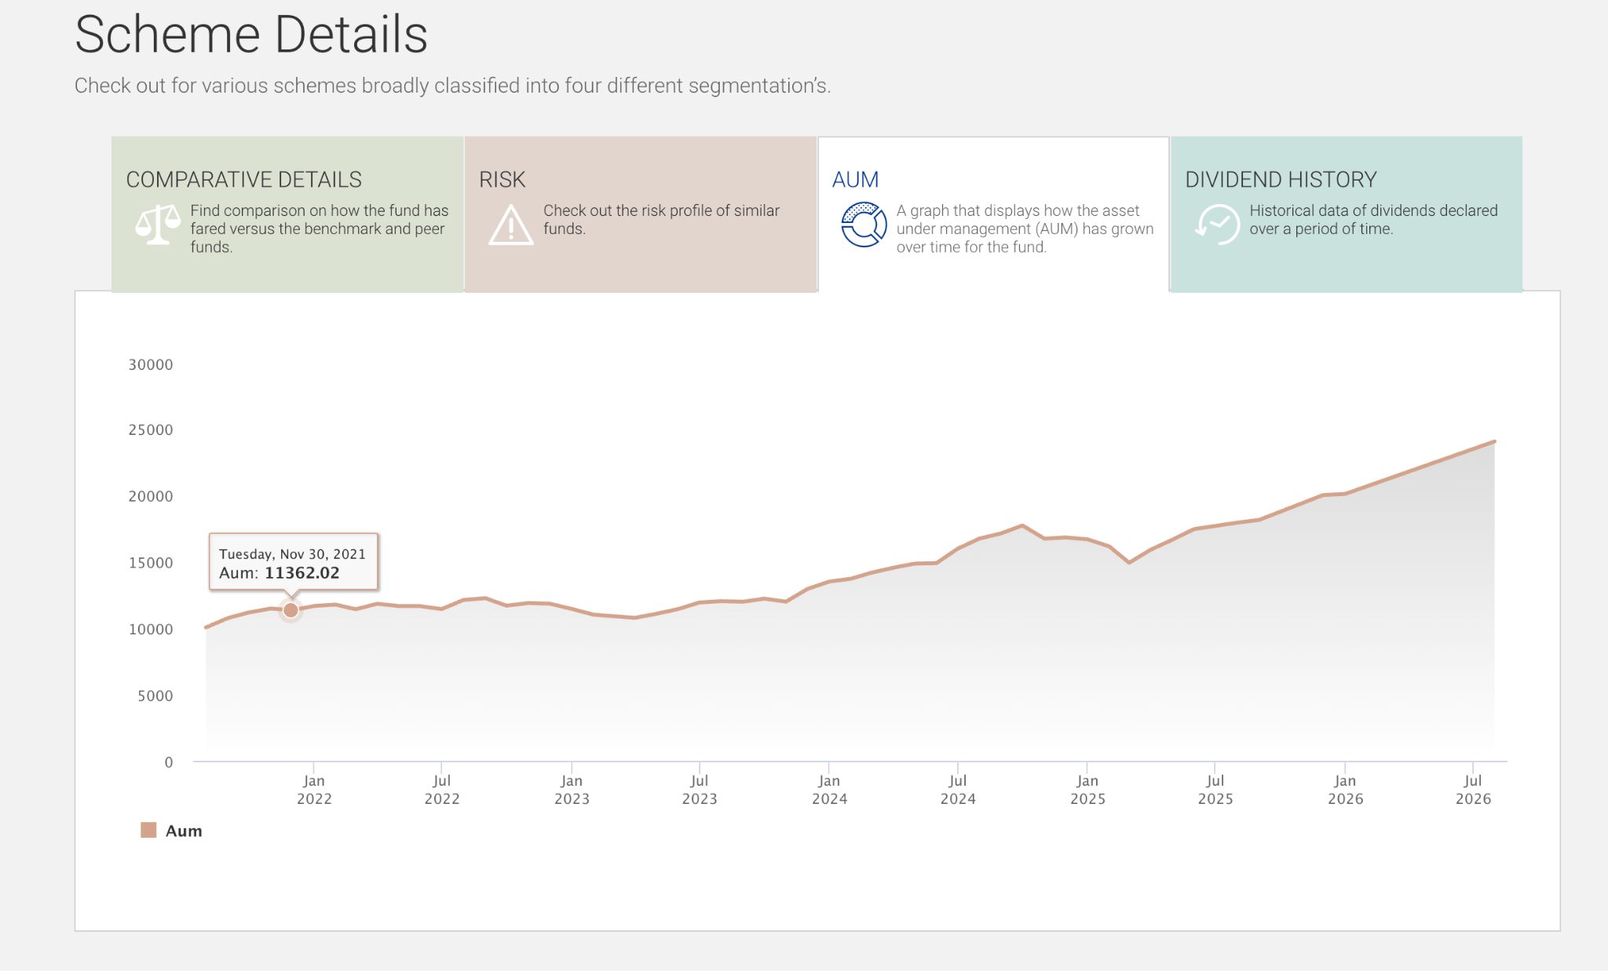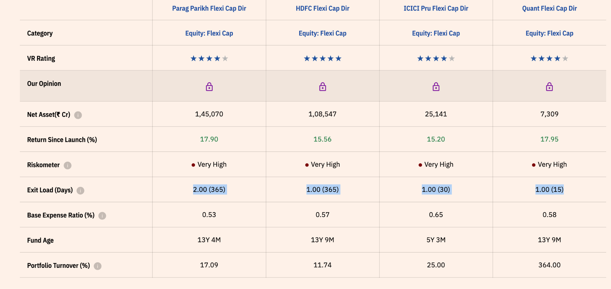
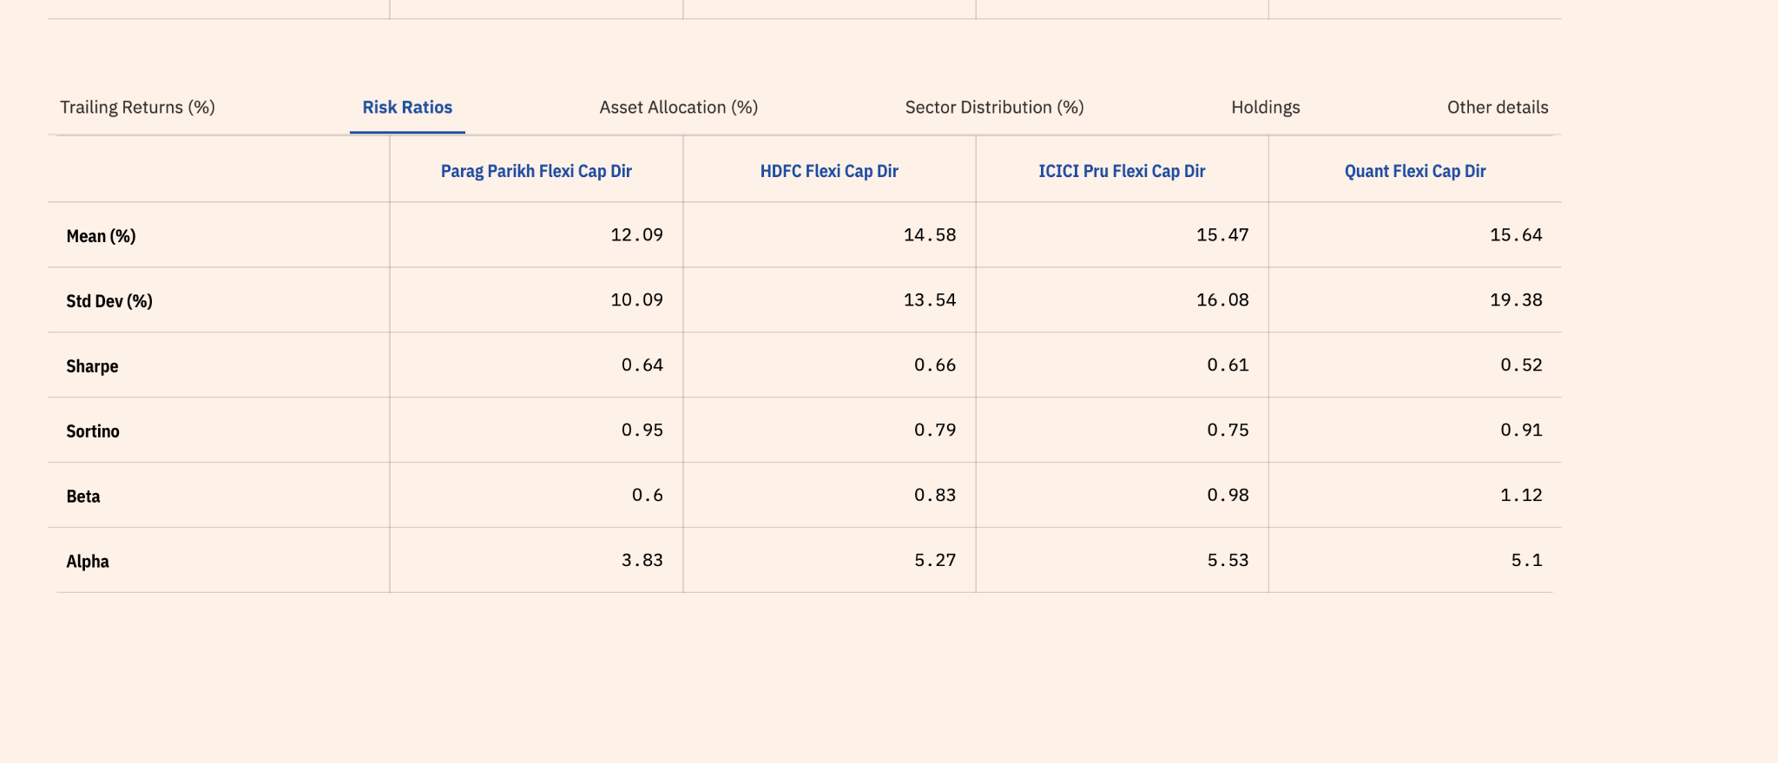
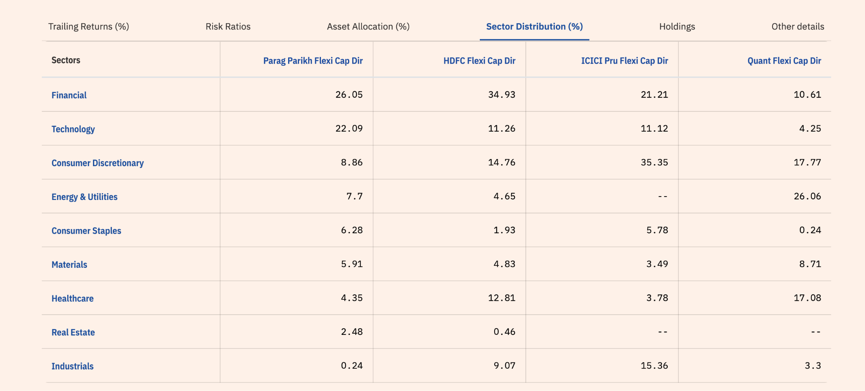
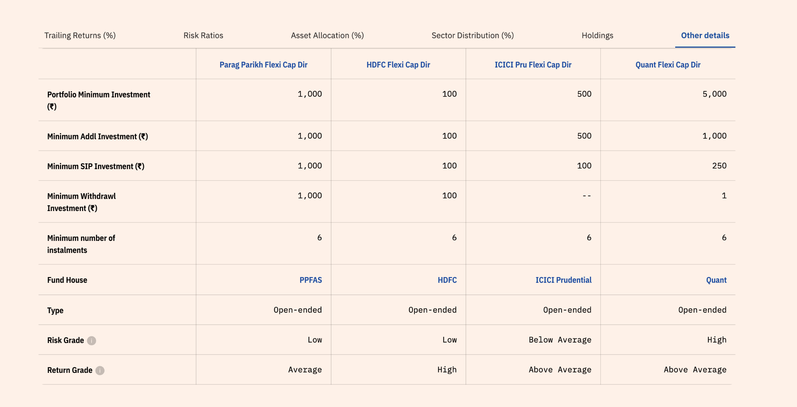

bit confusing make by will take more time to think on this flexi cap.
all these have 60+ in large cap

for now will continue to parag parikh definitely. out of icici, hdfc, quant. find out differnet form parig parikh how it different adding some value and whether require need to check. quant is like momentun drient ( seems not verified )

quant -> no believer of buy and hold, momentun driven, sectoral driven, vlrt franework, high risk high volitie, quant vs hdfc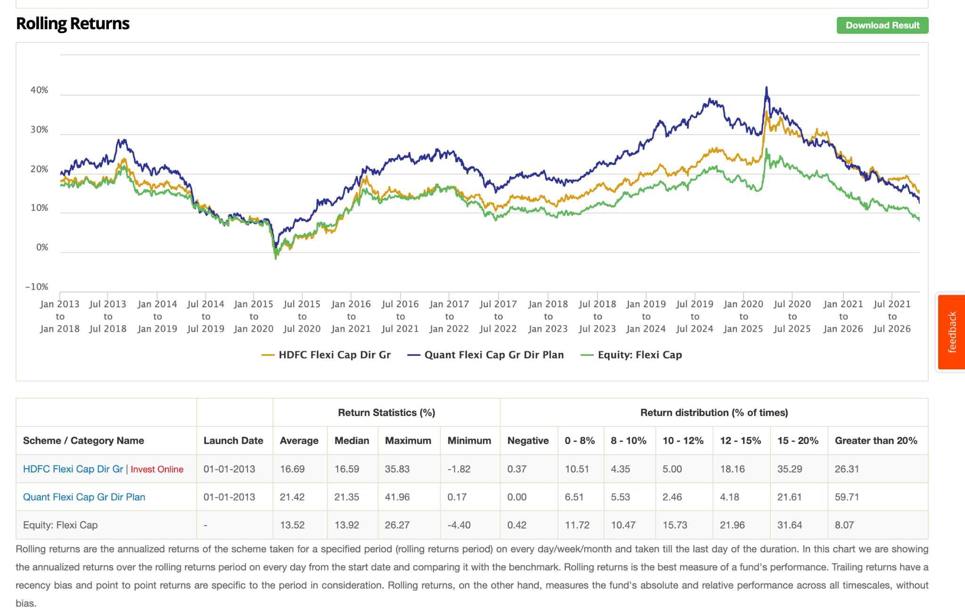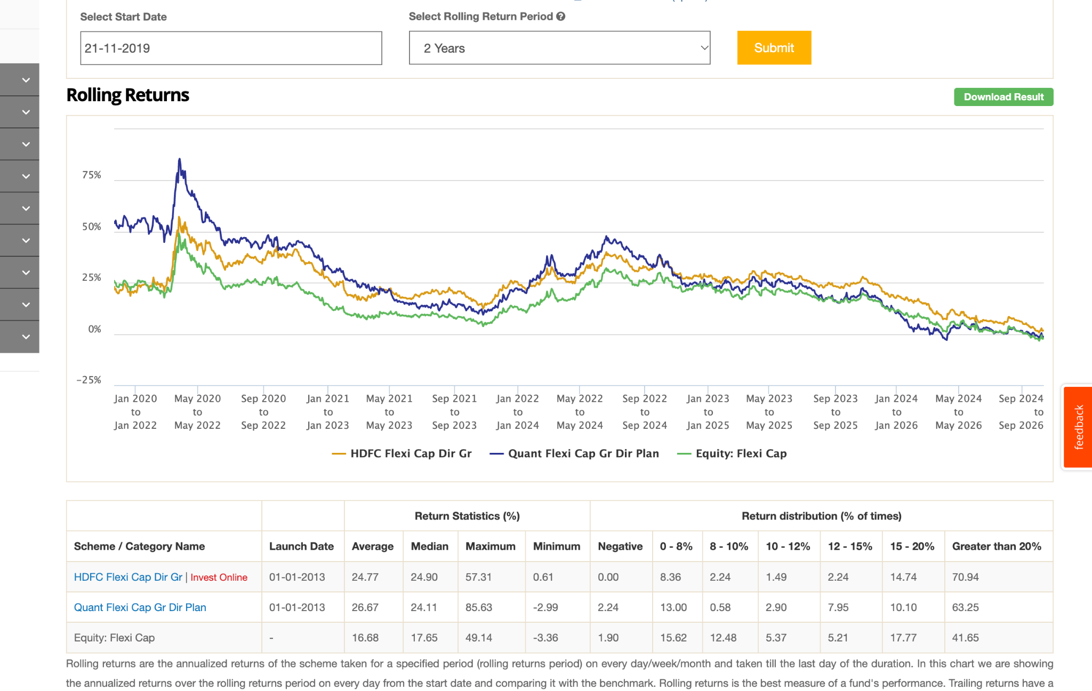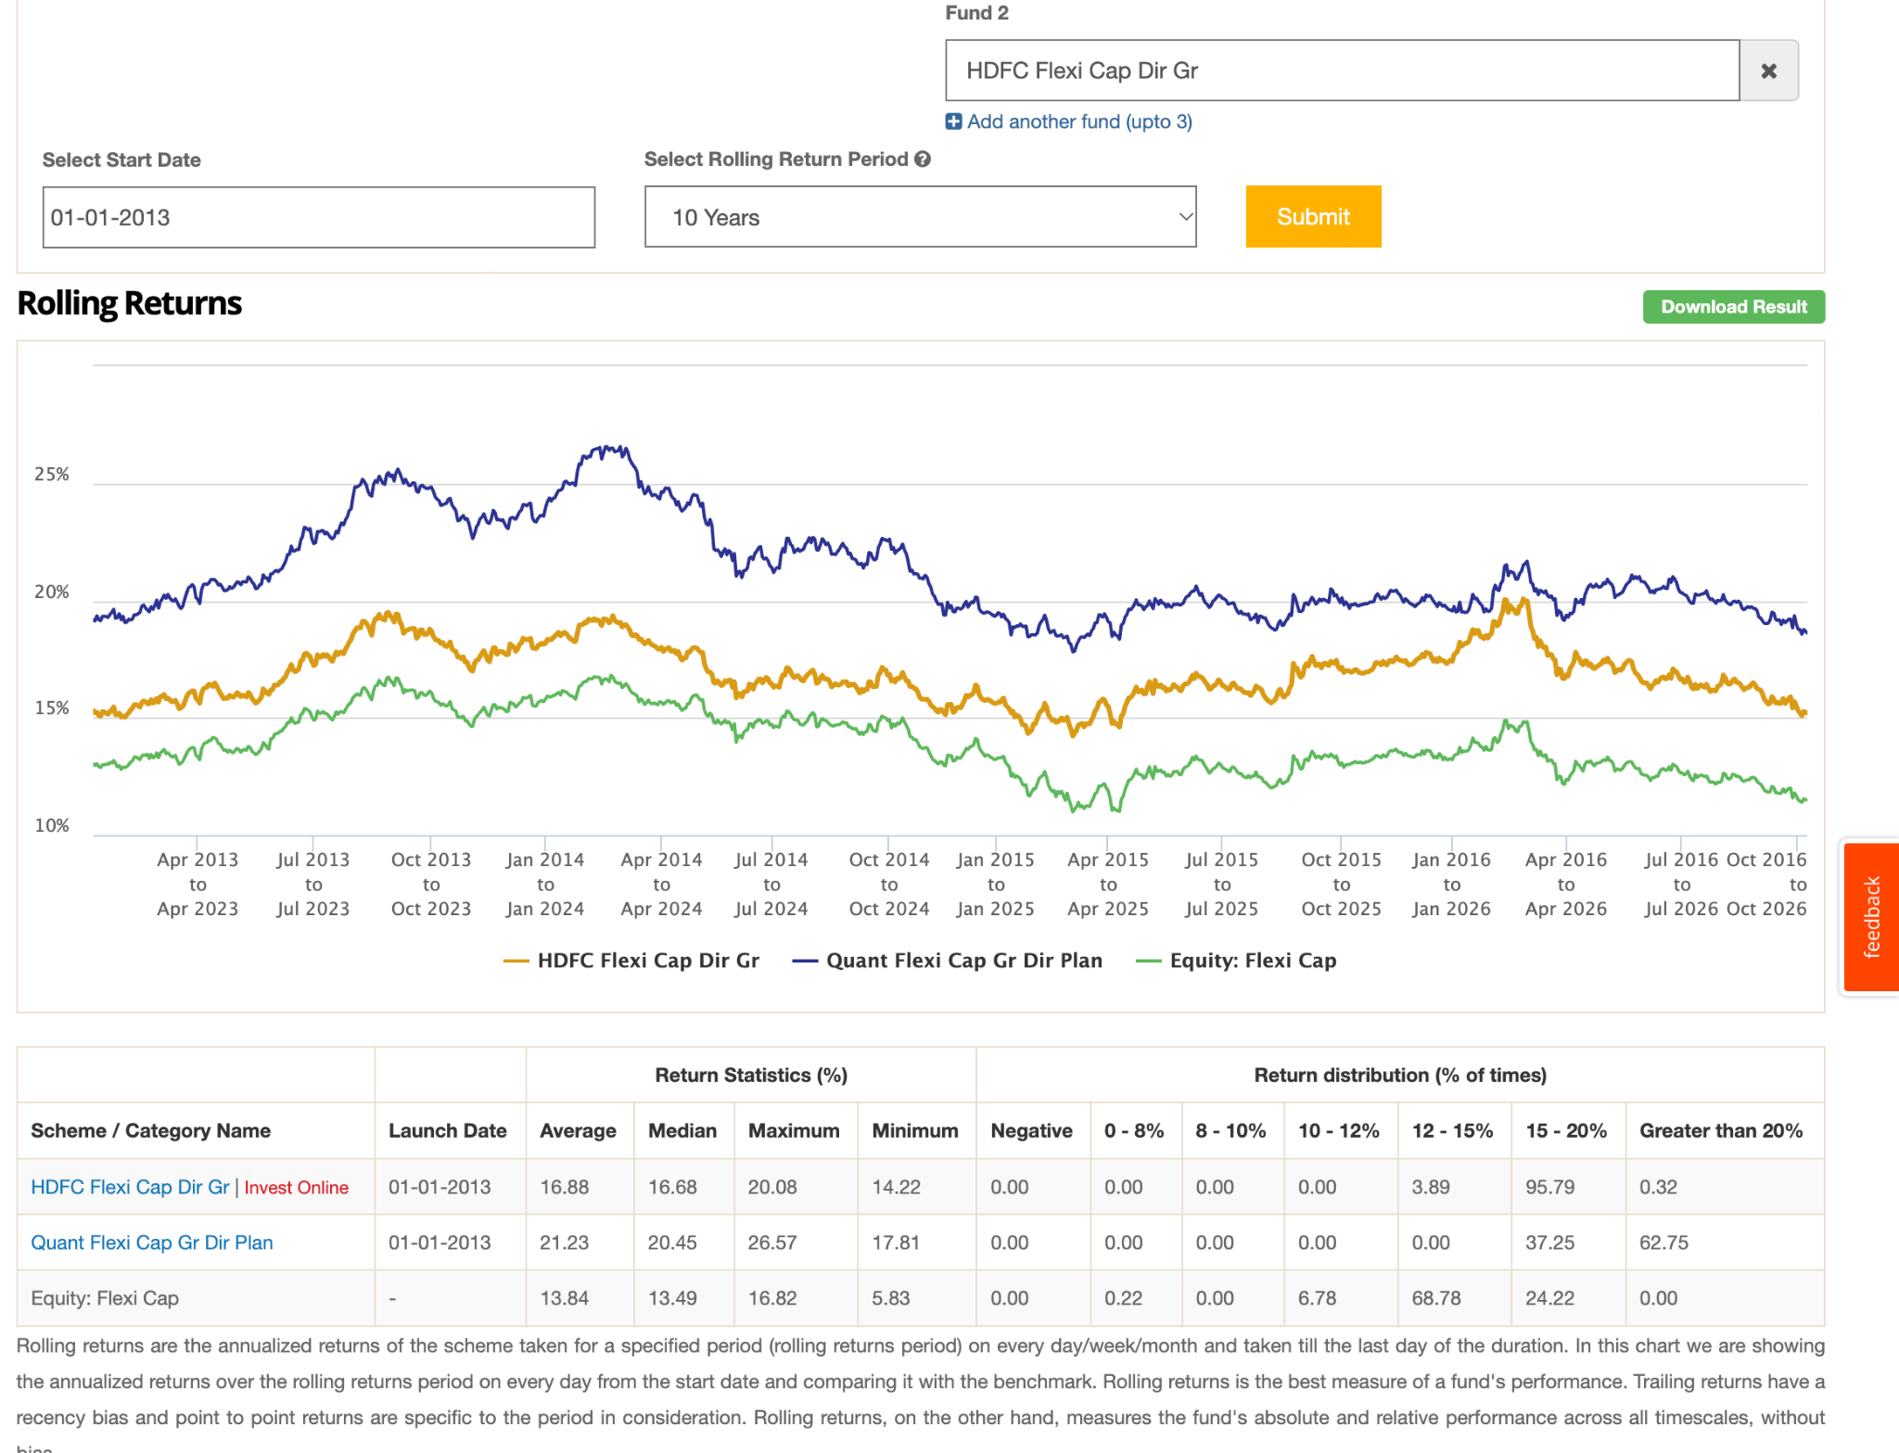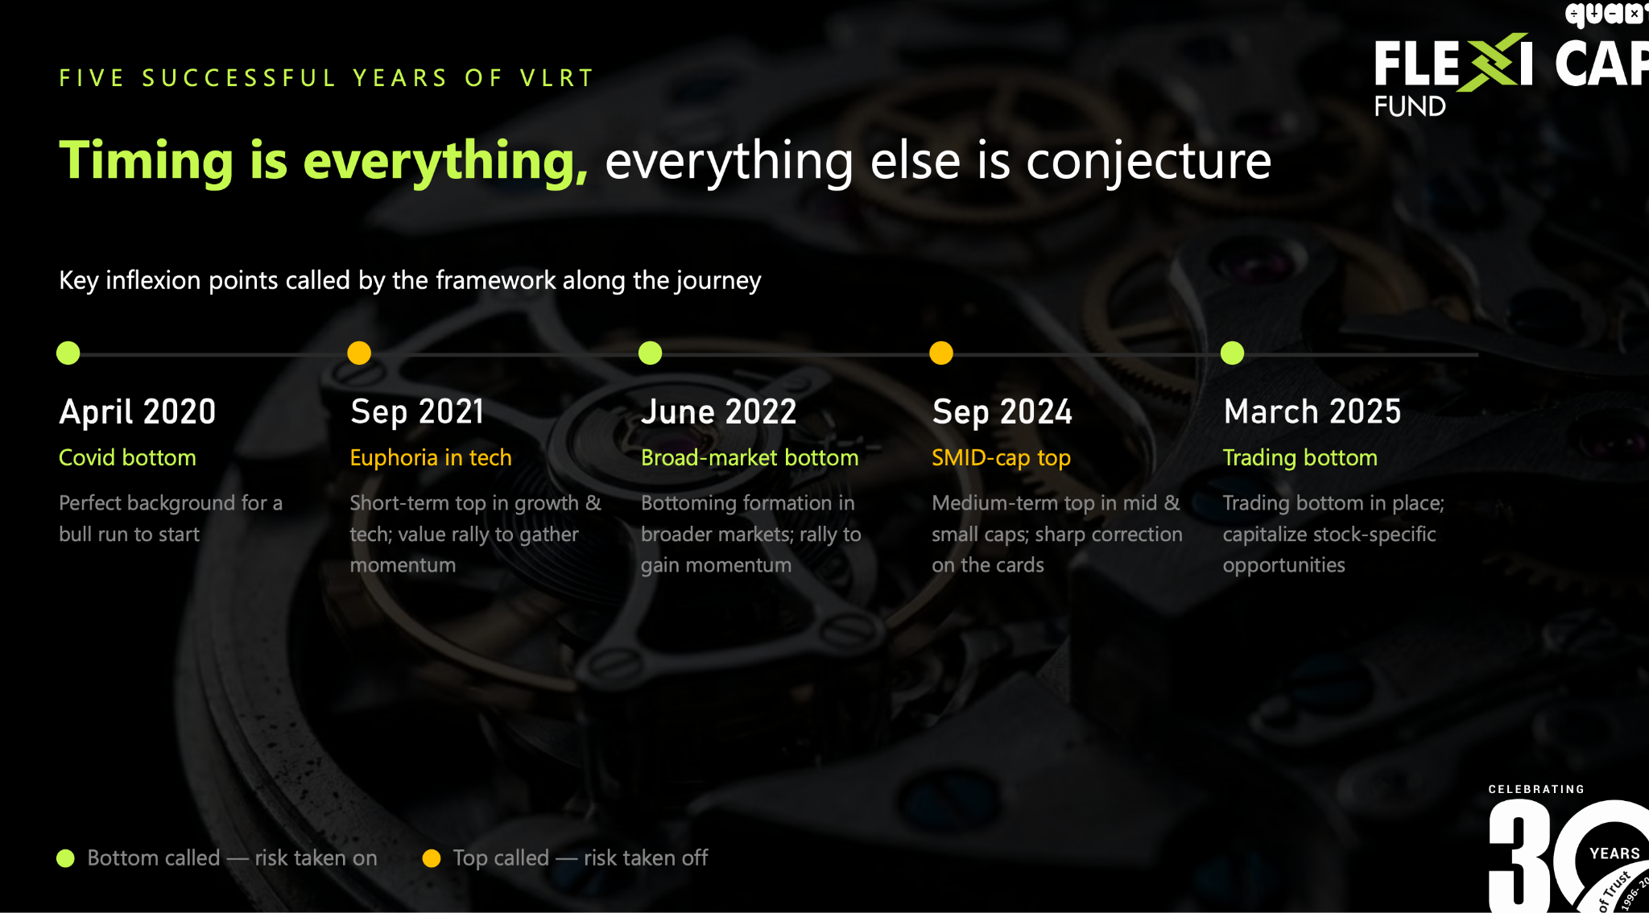 sandeep tandon
https://www.quantmutual.com/Admin/Pdf/quant_Flexi_Cap_Fund_Presentation-%20Updated.pdf

hdfc outperformin icic alwasy ( so don't going with icici )
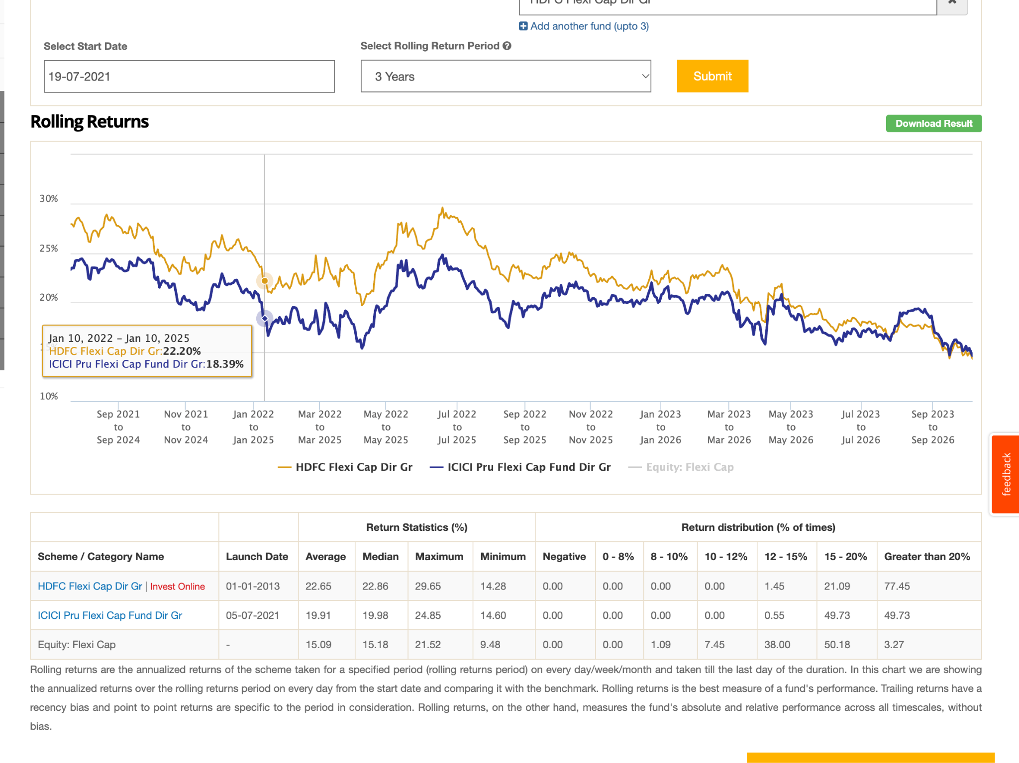
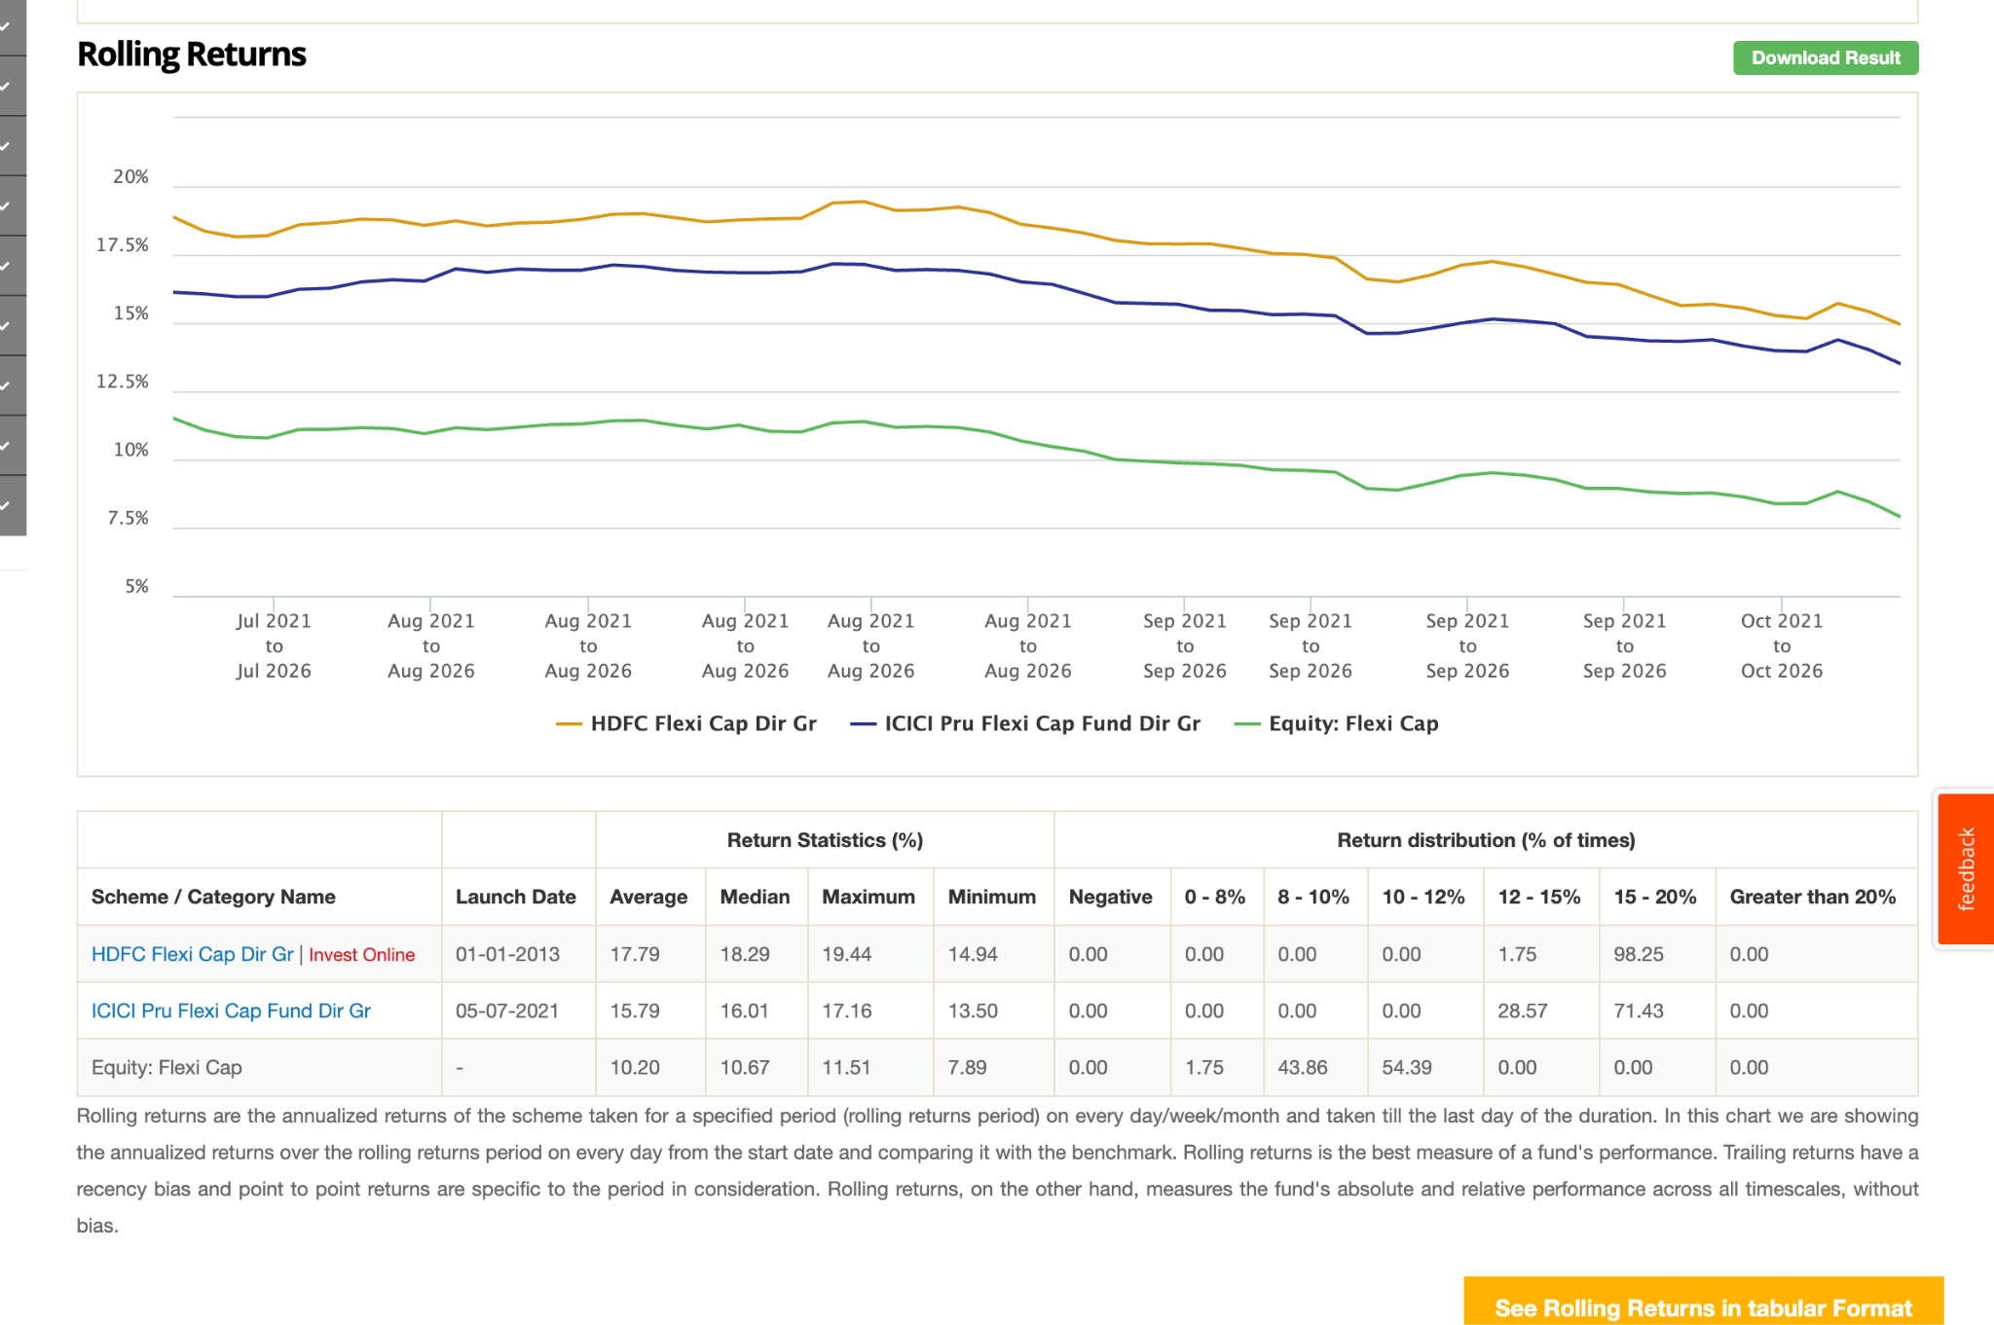

so now hdfc and quant. 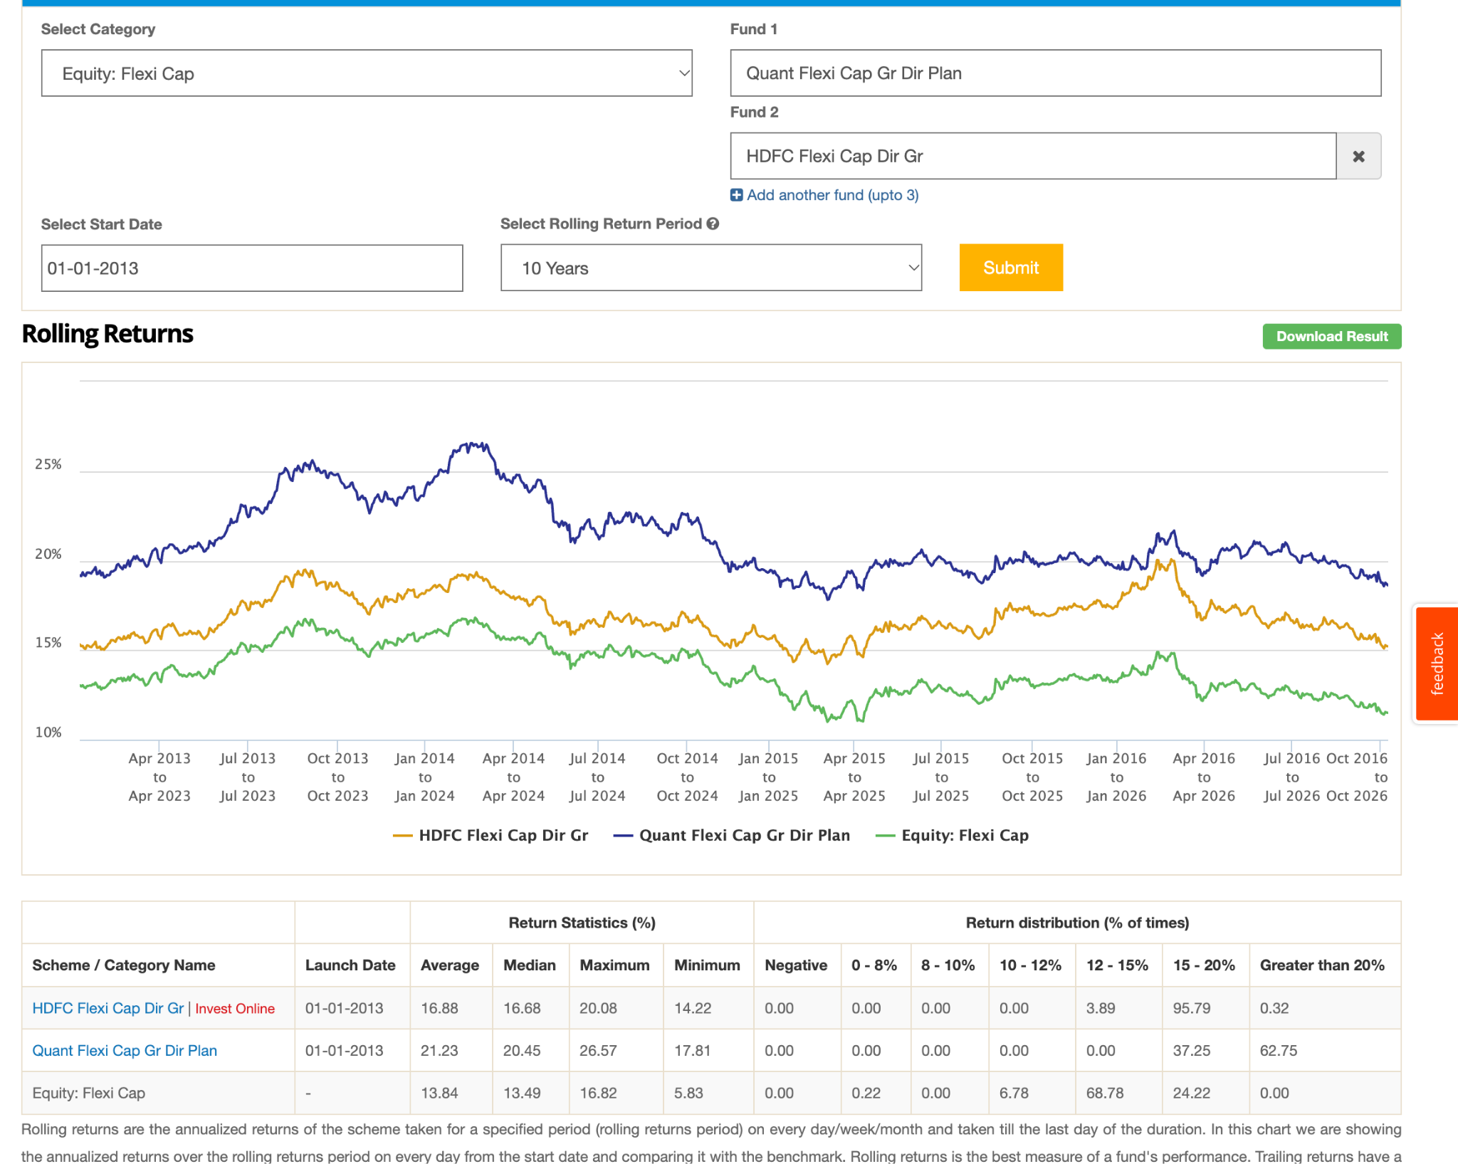
hdfc has changed fund manager in 2026, increased equity, mid and small propertion , no. of stock https://www.linkedin.com/posts/sridhar-kumar-sahu-a86a13140_hdfc-flexi-cap-is-changing-under-its-new-share-7492893120393789440-lLEn/

hdfc -> growth, kind of buy and hold
ppfcf -> value / blend, buy and hold,
quant -> momentun, no byy and hold if not require.
i might invest in quant but for know keep parag parikh.

